A PROJECT REPORT ON

“PREDICTIVE ANALYSIS OF CROP SUITABILITY U
SING DATA DRIVEN MACHINE LEARNING
MODEL”

SUBMITTED TO THE SAVITRIBAI PHULE PUNE UNIVERSITY, PUNE IN THE PARTIAL FULFILLMENT OF THE REQUIREMENTS
FOR THE AWARD OF THE DEGREE OF

BACHELOR OF ENGINEERING

SUBMITTED BY
- PIYUSH RAVI GORE Exam No: B400960
- SHUBHAM MAHESH JADHAV Exam No: B400960
- CHINMAY PRASHANT KULKARNI Exam No: B400960
- KIRAN SUBHAKAR PADGHAKAR Exam No: B400960

Under the Supervision of Prof. Vikas Gaikwad



DEPARTMENT OF ARTIFICIAL INTELLENGE AND DATA SCIENCE

SRES’ SHREE RAMCHANDRA COLLEGE OF ENGINEERING

LONIKAND, WAGHOLI, PUNE 412216 SAVITRIBAI PHULE PUNE UNIVERSITY 2025 -2026

SRES’ SHREE RAMCHANDRA COLLEGE OF ENGINEERINGLONIKAND, PUNE
DEPARTMENT OF ARTIFICIAL INTELLENGE AND DATA SCIENCE

CERTIFICATE

This is to certify that the project report entitles

“StegnoVault — A Web-Based Secure Data Transmission
System Using LSB Steganography”

Submitted by

- PIYUSH RAVI GORE Exam No: B400960
- SHUBHAM MAHESH JADHAV Exam No: B400960
- CHINMAY PRASHANT KULKARNI Exam No: B400960
- KIRAN SUBHAKAR PADGHAKAR Exam No: B400960

is a Bonafide student of this institute and the work have been carried out by them under the supervision of Prof. Vikas Gaikwad and it is approved for the partial fulfillment of the requirement of Savitribai Phule Pune University, for the award of the degree of Bachelor of Engineering (Artificial Intelligence And Data Science).

Prof. Yogita More Prof. Dr. N. A. Kumar
Guide HoD, Computer Engineering

External Examiner
Principal

SRCOE

Place: Pune Date:

ACKNOWLEDGEMENT

It gives me immense pleasure in expressing my deepest sense of gratitude towards my supervisor Prof. Yogita More, Department of Computer Engineering, Shree Ramchandra College of Engineering, Lonikand, Pune, for the continual support provided by her during the semester of my research. Her valuable guidance, timely suggestions and constant encouragement made it possible for me to complete this research work.
I take this opportunity to express my special gratitude to Honorable Management and Honorable Principal, Shree Ramchandra College of Engineering, Prof. Dr. Neelam Kumar, Head of Department of computer engineering for their motivation and support.
I am very much thankful to teaching and non-teaching staff from Shree Ramchandra College of Engineering, Lonikand, Pune who directly or indirectly helped me during my work.
Finally, I would like to acknowledge my family members for their continual support and encouragement.

SHWETA VIVEKANAND CHOUNDE Exam No: B400960074
TANUJA SANTOSH DHERE Exam No: B400960077
OM SUNIL GAIKWAD Exam No: B400960081
ZOHAIB KHAN RAFIQUE AHEMAD KHAN Exam No: B400960126
ABSTRACT

StegnoVault is a web-based secure data transmission system that enhances information security by combining cryptography, steganography, and optimization techniques into a unified framework. Unlike traditional methods such as AES and RSA that secure only the content, StegnoVault also conceals the existence of the message using Least Significant Bit (LSB) steganography. The system employs AES-256 encryption in CBC mode with PKCS5 padding to convert sensitive data into ciphertext, which is then intelligently embedded into digital media files (images, audio, and video) using a Genetic Algorithm to select high-entropy, non-sequential embedding positions. This dual-layer approach minimizes statistical detectability while ensuring data confidentiality and integrity. Accessible via a browser without requiring local installation, the platform provides a consistent and practical solution for secure communication. The integration of these advanced techniques results in a robust, efficient, and versatile system with applications in military communication, healthcare data protection, corporate security, and digital watermarking.

Keywords: Steganography, LSB (Least Significant Bit), AES-256 Encryption, Genetic Algorithm, Secure Data Transmission, Image Steganography, Audio Steganography, Video Steganography.

TABLE OF CONTENT

Certificate |  | ii
Acknowledgement |  | iii
Abstract |  | iv
Table of Contents |  | v
List of Figures |  | vi
List of Tables |  | vii
Sr. No. | Title | Page No.
1 | Introduction | 1
1.1 | Overview | 2
1.2 | Problem Statement | 3
1.3 | Objectives | 3
1.4 | Importance of Web-Based Applications | 3
1.5 | Global and Regional Context | 4
2 | Literature Survey | 7
3 | Software / Hardware Requirements Specification | 15
3.1 | Software Requirement | 15
3.2 | Software Interfaces | 17
3.3 | Functional Requirements | 18
3.4 | Non-Functional Requirements | 20
4 | System Design | 23
4.1 | System Architecture | 23
4.2 | ER Diagram | 25
4.3 | Data Flow Diagram | 27
4.4 | Class Diagram | 28
4.5 | Sequence Diagram | 29
4.6 | Collaboration Diagram | 30
4.7 | State Diagram | 31
4.8 | Component Diagram | 32
4.9 | Activity Diagram | 33
4.10 | Data Flow Diagrams (DFD 0, DFD 1, DFD 2) | 33
4.11 | Deployment Diagram | 35
5 | Algorithms | 36
5.1 | AES-256 Encryption Algorithm | 36
5.2 | LSB Steganography Algorithm (Image, Audio, Video) | 37
5.3 | Genetic Algorithm (GA) Optimization | 40
6 | Project Implementation | 43
6.1 | Project Steps | 43
6.2 | Working Model of Proposed System | 51
7 | Software Testing | 56
7.1 | Functional Testing | 56
7.2 | Security Testing | 59
7.3 | Performance Testing | 59
7.4 | Usability Testing | 60
7.5 | Regression Testing | 61
8 | Results | 62
8.1 | Image Steganography Results | 62
8.2 | Audio and Video Results | 63
8.3 | System Screenshots | 63
9 | Advantages and Disadvantages | 73
9.1 | Advantages | 73
9.2 | Disadvantages | 74
10 | Conclusions and Future Scope | 75
10.1 | Conclusion | 75
10.2 | Future Scope | 76
 | References | 77

LIST OF FIGURES

Figure No. | Figure Title | Page No.
Fig 4.1 | System Architecture of StegnoVault | 23
Fig 4.2 | ER Diagram (Entity Relationship Diagram) | 25
Fig 4.3 | Data Flow Diagram | 27
Fig 4.4 | Class Diagram — Secure Data Steganography System | 28
Fig 4.5 | Sequence Diagram — Secure Data Steganography System | 29
Fig 4.6 | Collaborative Diagram — Secure Data Steganography System | 30
Fig 4.7 | State Transition Diagram of Secure Data Steganography | 31
Fig 4.8 | Component Diagram of Secure Data Steganography | 32
Fig 4.9 | Activity Diagram of Secure Data Steganography | 33
Fig 4.10.1 | DFD 0 Diagram | 33
Fig 4.10.2 | DFD 1 Diagram | 34
Fig 4.10.3 | DFD 2 Diagram | 35
Fig 4.11 | Deployment Diagram | 35
Fig 5.1 | AES-256 Algorithm Flow | 37
Fig 5.2 | LSB Algorithm Flow for Three Media Types | 40
Fig 5.3 | Genetic Algorithm Flow Diagram | 42
Fig 5.4 | PSNR Comparison — GA-Optimized LSB vs Sequential LSB | 42
Fig 6.1 | Project Steps Diagram | 43
Fig 6.2 | Working Model of StegnoVault — Complete System Flow | 51
Fig 6.3 | Encoding Hub — Web Interface Screenshot | 53
Fig 6.4 | Decoding Hub — Web Interface Screenshot | 54
Fig 6.5 | Galaxy-Themed Dashboard — Screenshot | 54
Fig 6.6 | Admin Panel — Screenshot | 55
Fig 7.1 | Software Testing Flow Diagram | 61
Fig 8.1 | User Registration Page | 63
Fig 8.2 | OTP Verification Page | 64
Fig 8.3 | Login Page / Forgot Password Page | 64
Fig 8.4 | Galaxy-Themed Dashboard | 65
Fig 8.5 | Encoding Hub — Image Tab | 65
Fig 8.6 | Encoding Hub — Audio Tab | 66
Fig 8.7 | Encoding Hub — Video Tab | 66
Fig 8.8 | Stego-File Download | 67
Fig 8.9 | Decoding Hub — Image Tab | 67
Fig 8.10 | Decoded Message Display | 67
Fig 8.11 | Decoding Hub — Audio Tab | 68
Fig 8.12 | Decoding Hub — Video Tab | 68
Fig 8.13 | Activity Log Page | 69
Fig 8.14 | User Profile Page | 69
Fig 8.15 | Admin Panel — User List | 70
Fig 8.16 | Admin Panel — Activity Audit Trail | 70
Fig 8.17 | Admin Panel — Platform Statistics | 71
Fig 8.18 | Encoded Image Comparison — Cover vs Stego | 71
Fig 8.19 | Forgot-Password Setup Page | 72
Fig 8.20 | Unauthorized Credential Access (403 Page) | 72

LIST OF TABLES

Table No. | Table Title | Page No.
Table 3.1 | Client Device Requirements | 15
Table 3.2 | Backend Infrastructure Requirements | 16
Table 3.3 | Network Infrastructure Specifications | 17
Table 3.4 | Functional Requirements | 18
Table 3.5 | Non-Functional Requirements | 20
Table 5.1 | GA Configuration Parameters | 40
Table 5.2 | Performance Results — GA-Optimized vs Sequential LSB | 42
Table 7.1 | System Test Cases with Expected and Actual Results | 57
Table 7.2 | Performance Testing Results | 60
Table 8.1 | Image Steganography Results — PSNR, MSE, and SSIM | 62

Chapter 1 Introduction

INTRODUCTION

Introduction

Agriculture is the backbone of India's economy, with sugarcane farming playing a crucial role in rural livelihoods. However, traditional methods of managing farmer factory interactions often lead to inefficiencies, delays, and a lack of transparency in financial transactions. To address these challenges, we have developed the Sugar Factory Application, a digital solution aimed at streamlining communication and financial management for farmers associated with sugar factories.
Currently, our focus is on the Farmer Module, which serves as a centralized platform for farmers to track their transactions, receive timely updates, and engage directly with factory administrators. This module is designed to replace manual recordkeeping and paper-based notifications with an automated system that enhances transparency and efficiency. By integrating technology into the sugarcane industry, the application helps bridge the gap between farmers and factories, ensuring smooth operations and better financial planning.
The Farmer Module enables farmers to log in securely using a role-based authentication system. This ensures that only authorized users can access their financial records and other personalized information. Upon logging in, farmers can view their transaction history, which includes details of payments received for their sugarcane deliveries. This feature eliminates the need for manual bookkeeping and provides a clear, real-time overview of financial transactions.
In addition to financial management, the Farmer Module also includes a support and query resolution system. Farmers can submit their concerns directly through the application, allowing them to seek clarification on payments, deliveries, or factory policies. This eliminates the need for in person visits to the factory, saving time and effort. The support system ensures that all queries are addressed promptly, fostering better communication between the farmers and factory management.
The implementation of this module is expected to bring several benefits to farmers. By enhancing financial transparency, it minimizes disputes related to payments and dues. The support services reduce dependency on intermediaries and minimizes miscommunication. Furthermore, by

digitizing these processes, the application contributes to a paperless and ecofriendly approach in managing sugarcane transactions.
This project is particularly significant in the context of modernizing agriculture and promoting digital transformation in rural areas. The adoption of digital solutions in farming communities can lead to improved efficiency, better financial literacy, and stronger integration with the broader economy. While the Farmer Module is the first phase of our Sugar Factory Application, it sets a strong foundation for future enhancements, such as predictive analytics for yield estimation, market price trends, and advanced reporting tools.
In conclusion, the Sugar Factory Application's Farmer Module is a step towards empowering farmers by providing them with a user-friendly, transparent, and efficient platform for managing their transactions. By leveraging technology, we aim to simplify financial processes, improve communication, and contribute to the overall growth of the sugarcane industry.

Overview

The Sugar Factory Application is developed to digitize and streamline interactions between farmers and sugar factories. Traditional systems rely heavily on manual recordkeeping, which often leads to inefficiencies, miscommunication, and payment delays. This application aims to solve these challenges by providing a centralized, digital platform for farmers to manage their transactions, receive updates, and communicate effectively with factory management.
The Farmer Module is the primary focus of this phase of development. It includes the following key features:
  - Farmer Registration and Authentication: Farmers can securely register and log in using role-based access control.
  - Transaction History Management: Farmers can view detailed records of their sugarcane deliveries and corresponding payments.
  - RealTime Notifications: Automated alerts inform farmers about payment updates, dues, and factory-related announcements.
  - Support and Query System: Farmers can submit concerns and receive responses from factory management within the application.

This module enhances financial transparency, reduces paperwork, and improves communication between farmers and sugar factories. By integrating these digital features, the application simplifies essential processes and ensures that farmers have real-time access to crucial information.
Future updates may expand the platform to include more advanced features like predictive analytics for yield estimation and enhanced market insights. However, the current implementation focuses entirely on streamlining financial transactions and communication for farmers, ensuring they receive timely updates and have easy access to their payment history.

Problem Statement

To develop a mobile application for Sugar Factory’s Farmers.

Objectives

  - To develop a mobile application that serves the dual purpose of connecting shareholders with essential financial information and supporting farmers with agricultural practices and price updates.
  - To act as a unified portal where shareholders can track dividends, share prices, and other relevant data while farmers receive advice on sugarcane farming, weather forecasts, and market prices.
  - To create a platform for real-time communication between farmers and shareholders.
  - To provide access to crucial data, including sugar prices, production reports, and market trends.

Importance of Android Applications
Android applications play a crucial role in modern digital life, offering numerous benefits across personal, business, and societal levels.

Widespread Accessibility
Android powers over 70% of smartphones worldwide, making Android apps highly accessible to users across diverse regions, especially in developing countries where Android devices are more affordable than iOS alternatives.

Business Growth and Revenue
Businesses leverage Android apps for marketing, customer engagement, sales, and support. Apps help companies reach a larger audience, increase brand visibility, and offer services 24/7, often leading to increased revenue and customer loyalty.

Customization and Innovation
Android’s open-source nature allows developers to innovate and customize apps extensively. This flexibility supports a wide range of applications, from gaming and e-commerce to education and healthcare.

Convenience and Efficiency
Android apps enhance everyday tasks—banking, navigation, communication, shopping, learning, and more—making them faster and more convenient. They help individuals manage work, health, and entertainment on-the-go.

Support for Emerging Technologies
Android apps often integrate cutting-edge technologies such as AI, IoT, AR/VR, and machine learning, enabling smarter, more personalized, and efficient user experiences.

Global and Regional context of Android Applications

Global Context

- Dominant Mobile OS: Android is the world’s most widely used mobile operating system, with over 70% global market share as of 2025. It is used in smartphones, tablets, TVs, wearables, and IoT devices, making Android apps central to global digital connectivity.
- Global Developer Ecosystem: Google Play Store offers millions of apps developed by a vast global community. Android’s open-source nature (AOSP) fosters innovation and international collaboration, making it easier for developers to create localized and scalable solutions.
- Cross-Industry Use: Android applications support sectors such as:
  - Healthcare (e.g., telemedicine, health tracking)
  - Education (e.g., e-learning apps like Google Classroom)
  - Finance (e.g., digital wallets and banking apps)
  - Retail & E-commerce (e.g., Amazon, Flipkart)

- Economic Impact: Android apps contribute significantly to the digital economy by creating jobs, enabling startups, and generating revenue through in-app purchases, ads, and subscriptions.

Regional Context (with example: India)
- Affordable Smartphone Penetration: In regions like South Asia, Africa, and Latin America, Android dominates due to affordable devices. In India, over 90% of smartphones run Android, enabling mass adoption of mobile apps for communication, education, and commerce.
- Localized Development: Regional developers create apps in local languages (e.g., Hindi, Tamil, Bengali), addressing specific cultural, linguistic, and societal needs—like government services (Aarogya Setu, DigiLocker) or regional news and entertainment.
- Support for Local Economies: Android apps empower small businesses and rural users through mobile banking, digital payments (e.g., UPI apps in India), and online marketplaces.
- Government and Policy Support: Many governments support Android-based app development for public service delivery, especially in developing nations with mobile-first strategies.

Continent-wise distribution and context
- Asia
  - Market Share: ~85%

Highlights:
    - Largest smartphone market (India, China, Indonesia).
    - Dominance due to affordable Android phones.
    - High adoption of mobile banking, e-commerce, and education apps.
    - Local apps like Paytm, WeChat, Gojek cater to regional needs.
    - Major hub for Android development (India and China).

Africa
  - Market Share: ~90%

Highlights:

    - Android is the primary gateway to the internet.
    - Used for mobile money (e.g., M-Pesa), healthcare, and agriculture apps.
    - Supports local development and language-based apps.
    - Low-cost smartphones and offline-first apps drive growth.

Europe
  - Market Share: ~70%

Highlights:
    - Balanced Android-iOS competition in Western Europe.
    - Android preferred in Eastern Europe due to affordability.
    - Strong focus on data privacy and GDPR compliance in apps.
    - Popular for productivity, health, and smart home apps.

North America
  - Market Share: ~45% (lower than global average)

Highlights:
    - iOS leads in the U.S., but Android is strong in Mexico and Canada.
    - Used for entertainment, productivity, and smart devices.
    - High standards for app quality, security, and UX design.

South America
  - Market Share: ~85%

Highlights:
    - Android leads due to economic affordability.
    - Popular in Brazil, Argentina, and Colombia.
    - Apps focus on transport (e.g., ride-hailing), fintech, and communication.

Australia & Oceania
  - Market Share: ~60%

Highlights:
    - Higher income allows choice between Android and iOS.
    - Android used widely in urban and remote areas.
    - Focus on health, weather, agriculture, and travel apps.

Chapter 2 Literature Survey

LITERATURE SURVEY

Title: Human Asset Management at the Endo Life Phase

Author: Piangor Loahavilai, Nopasit Chakpitak, Thunyaporn Jaimung

The paper "Human Asset Management at the End-of-Life Phase" explores the challenges and strategies for managing older workers in a factory setting, particularly focusing on a semiconductor assembly company in Thailand. The central issue addressed is the perception among management and shareholders that older employee, especially those in their late 40s and beyond, are less productive due to physical deterioration. However, the paper argues that while physical abilities may decline, intellectual competence and decision-making skills improve with age, suggesting that older workers still provide significant value.
The study is set within the context of a Korean multinational enterprise that had invested in a semiconductor assembly factory in Thailand. By 2015, over half of the production workers were aged 45 or older, having worked for the company for more than 16 years. The management, drawing from experiences in Korea where workers typically retired earlier, expressed concerns over the aging workforce.
In response to these concerns, the company introduced initiatives like tight performance evaluations and early retirement programs aimed at reducing the number of older workers. Despite this, a recovery in the semiconductor market in 2016 led to increased demand, resulting in the recruitment of younger workers and a reshaping of the workforce's age structure. By mid2017, the percentage of older workers had decreased, though management remained concerned about the remaining senior employees. The paper introduces the concept of Reliability Centered Manpower (RCM), adapted from Reliability Centered Maintenance, typically used for machinery.
This approach provides a systematic method for evaluating whether an older worker should be retained or replaced, based on their physical and intellectual abilities, as well as their overall contribution to productivity. RCM involves classifying workers by age and job function, evaluating their service performance, and estimating the cost of replacing them with new hires. The study concludes that, although older workers may physically decline, their intellectual and decision-making skills improve over time. This highlights the importance of managing human

assets wisely, acknowledging both the tangible and intangible contributions that older workers make.
The proposed RCM model provides a framework for companies to assess these workers' potential and make informed decisions about their employment at the end of their careers. The model proposed in the study seeks to offer a fair and rational tool for deciding the future of older workers in the company. It recognizes that while older employees may face physical challenges, their accumulated knowledge and expertise often make them valuable assets. The RCM approach balances these factors to ensure that decisions regarding early retirement or retention are made in the best interest of both the company and the employees.
Title: Determinant Of Labor Supply in Metehara Sugar Factory Case Study on Metehara Sugar Factory
Author: Abdella Mohammed Ahmed

The study, "Determinant of Labor Supply in Metahara Sugar Factory: A Case Study," investigates the factors influencing labor force participation in Ethiopia’s Metahara Sugar Factory. Conducted by Abdella Mohammed Ahmed, it explores how personal, social, and economic determinants affect the decision to participate in the workforce.
The study addresses key questions on what drives labor supply in the factory, focusing on variables like age, education, marital status, income level, fertility, and migration status. Using both primary data from surveys and secondary data from factory records, the research reveals that younger workers, particularly those aged 2529 for men and 3034 for women, have the highest participation rates. Education is a crucial factor, with higher levels of vocational or technical training (TVT) linked to increased participation, although there is a significant gender gap in educational attainment. Income potential also plays a significant role, with workers who anticipate higher earnings showing more willingness to participate actively in the labor market.
Marital status affects participation rates as well, particularly for men, with married individuals being more likely to engage in work. For women, household responsibilities such as childrearing often reduce their participation, especially in larger households. Migration status is another

determinant, with migrants seeking better job opportunities showing higher participation rates compared to nonemigrants.
The study highlights the positive effects of education, income potential, and migration, while noting the negative impact of household size and aging on female labor participation. The research concludes with recommendations to enhance education, provide continuous training, and implement family planning programs to reduce dependency ratios, which would ultimately improve labor supply and productivity in the Metahara Sugar Factory.
Title: Research on Integrated Design Platform of Sugarcane Harvester

Author: Yang Nianjiong

The paper, Research on Integrated Design Platform of Sugarcane Harvester, authored by Yang Nianjiong, explores the development of a comprehensive design platform for sugarcane harvesters. The motivation stems from the challenges in harvesting sugarcane, particularly in the hilly terrains of southern China, such as Guangxi, where manual harvesting is labor-intensive and costly.
The need for a mechanized solution, particularly a Mini type sugarcane harvester, is emphasized to increase productivity and reduce costs. The key focus of the paper is the development of an integrated design platform using advanced computer aided technologies—CAD (Computer Aided Design), CAE (Computer Aided Engineering), CAPP (Computer Aided Process Planning), and CAM (Computer Aided Manufacturing). These are linked through a Product Data Management (PDM) system, which ensures data consistency, integration, and security.
The platform is developed using Visual Studio.net, and its effectiveness is demonstrated through a design example of a wheel type sugarcane harvester. The platform provides a streamlined environment where designers can efficiently design, analyze, simulate, and modify components, resulting in faster design cycles and reduced development costs. Designers access the platform via a local area network (LAN), with all data and files being stored in a unified PDM database. This centralized system enables seamless data sharing across the various modules (CAD, CAE, CAPP, CAM) and the intelligent design system of the sugarcane harvester. The PDM system ensures version control, manages the lifecycle of design files, and facilitates the transfer of data between different software modules.

The integrated platform also incorporates a knowledge base and an example library, which help designers leverage previous successful designs. This feature aids in improving design efficiency by allowing the reuse of proven design elements and solutions. The data transmission model within the platform ensures compatibility between different software tools and formats, enabling smooth communication between systems.
In conclusion, the integrated design platform developed in this research provides a significant advancement in the design and development of sugarcane harvesters. By leveraging computer aided technologies and PDM, the platform accelerates the design process, enhances data management, and ultimately improves the efficiency of developing complex electromechanical products like sugarcane harvesters.
Title: Predicting Total Sugar Production Using Multivariable Linear Regression

Author: Santosh Kr. Gupta, Dr. Arun Prakash Agarwal

The paper titled "Predicting Total Sugar Production Using Multivariable Linear Regression" explores the application of multivariable linear regression to predict sugar production in India. Authored by Santosh Kr. Gupta and Dr. Arun Prakash Agarwal, it addresses the complexity of forecasting sugar production, a crucial commodity produced in over 110 countries, with India being the largest producer. Accurate prediction of sugar production helps manage agricultural risks, optimize planting areas, and improve business decision-making.
The study utilizes historical data from 1931 to 2018, collected from the ICAR – Sugarcane Breeding Institute, Coimbatore. The dataset includes 12 attributes, such as area under sugarcane, yield per hectare, number of operational factories, and total cane crushed. Of these, multivariable linear regression is used to forecast total sugar production, with the total sugar production as the dependent variable and the selected parameters as independent variables. To enhance the prediction accuracy, data preprocessing involved filling missing values with median values and removing unnecessary data points. After that, a heatmap was employed to find correlations between attributes, followed by backward elimination to identify the most significant predictors.
The study found that three variables—total cane crushed, average capacity, and production of cane—are the key predictors for total sugar production. The multivariable regression model is

applied to these significant features, predicting the total sugar production with an accuracy of 97.23%. The proposed model divides the data into 80% for training and 20% for testing, applying Min Max Scaler for normalization. The final equation for predicting total sugar production is derived from a linear combination of the significant predictors. Visual graphs illustrate the linear relationships between total sugar production and the independent variables, confirming the model’s reliability.
The paper concludes that the developed model is highly effective in predicting sugar production and can be useful for decision-making in the sugar industry. The accurate prediction provided by the model can help optimize resource allocation and improve productivity across the sugarcane industry, particularly in countries like India, where sugarcane is a major agricultural product.
Title: Irrigation and fertigation scheduling effect on phenology and yield of spring sugarcane (Sachharum officinarum)
Author: Hari Singh, R K Singh

The paper titled "Irrigation and Fertigation Scheduling Effect on Phenology and Yield of Spring Sugarcane (Saccharum officinarum)" by Hari Singh and R.K. Singh explores the impact of irrigation methods and nitrogen fertilization scheduling on the growth and yield of sugarcane in India. Conducted at the Agricultural Research Farm of Banaras Hindu University, the study aimed to identify the most effective irrigation and nitrogen management practices to maximize sugarcane productivity, which is a crucial crop for India’s agricultural economy. The experiment was structured using a split plot design over two consecutive growing seasons (2016-2018). It compared three irrigation methods—flood, furrow, and drip irrigation—with five nitrogen scheduling techniques. These nitrogen treatments involved the application of nitrogen in different numbers of split doses: farmers’ practice (two applications), and split applications in 4, 6, 8, and 10 intervals.
The goal was to evaluate which irrigation and nitrogen application methods produced the highest yield and most favorable growth parameters. The results showed that drip irrigation significantly outperformed both flood and furrow irrigation, resulting in higher germination rates, more tillers, a larger leaf area index, and better overall crop growth. In terms of nitrogen

application, six splits of nitrogen proved to be the most effective, leading to the highest number of tillers, improved leaf area, and greater chlorophyll content compared to the farmers' practice and other nitrogen schedules.
This suggests that regular, split nitrogen application at 20day intervals is optimal for sugarcane growth. Yield attributes such as internode length, cane weight, and the number of mill able canes also significantly improved under drip irrigation and with six splits of nitrogen. Drip irrigation increased cane yield by 22.3% compared to flood irrigation. The study further revealed that the six split nitrogen application led to a 10.09% higher yield compared to traditional farmers’ practices. Although irrigation methods did not significantly affect the quality parameters like commercial cane sugar and fiber content, drip irrigation exhibited the highest fiber percentage (13.78%).
The research concludes that combining drip irrigation with a six split nitrogen application schedule is the most effective strategy for maximizing both the growth and yield of sugarcane. This approach optimizes water and nutrient use, contributing to more sustainable and productive sugarcane farming, especially in water scarce regions.
Title: Development of an Approach for Monitoring Sugarcane Harvested and NonHarvested Conditions Using Time Series Sentinel1 Data
Author: Deepak Murugan, Dharmendra Singh

In the “Development of an approach for monitoring sugarcane harvested and NonHarvested conditions using time series sentinel1 data” the authors proposed that remote sensing technologies, including multispectral and hyperspectral imaging, can be effectively utilized for monitoring sugarcane growth and health. Traditional field-based monitoring methods are labor-intensive, costly, and time-consuming, making remote sensing a more efficient and scalable alternative for large agricultural areas.

The study explores different remote sensing techniques, such as satellite imagery, drone-based sensing, and ground-based sensors, which provide valuable insights into crop growth patterns. These technologies assess vegetation indices like the Normalized Difference Vegetation Index (NDVI), Enhanced Vegetation Index (EVI), and Leaf Area Index (LAI), which are crucial for evaluating plant health, growth stages, and biomass estimation. Remote sensing enables early

detection of crop stress, which can be caused by nutrient deficiencies, water shortages, pest infestations, and diseases.

One of the key aspects highlighted in the study is the application of hyperspectral imaging, which captures detailed spectral reflectance data. By analyzing changes in chlorophyll content and water levels, hyperspectral imaging allows for precise monitoring of sugarcane health, enabling farmers to take early corrective actions. The integration of Geographic Information Systems (GIS) with remote sensing data further enhances precision agriculture by mapping sugarcane fields and optimizing irrigation, fertilization, and pest control strategies.

The research concludes that remote sensing significantly improves sugarcane farm management by providing timely and accurate crop health information. This technology plays a critical role in yield prediction, resource optimization, and cost reduction, making sugarcane farming more efficient and sustainable. The study also suggests that the integration of remote sensing with machine learning algorithms can enhance the accuracy of growth monitoring, stress detection, and disease prediction.

Title: A Research and Practice for Sugarcane Area's Farm Management Information Service Platform
Author: Liang Yu, Luo Yongjun

In the study “a research and practice for sugarcane area's farm management information service platform (2010)”, the authors propose a comprehensive farm management information service platform to enhance sugarcane production efficiency, improve yield and quality, and ensure the freshness of harvested sugarcane. The study highlights the challenges faced in traditional sugarcane farm management in China, including high production costs, inefficient harvesting and transportation, and poor coordination among farmers, enterprises, and government agencies. To address these issues, the authors introduce a modern information system that integrates Remote Sensing (RS), Geographic Information Systems (GIS), Global Positioning Systems (GPS), and Web Services.

The study discusses the successful implementation of this platform in a demonstration area within Guangxi, one of China's leading sugar producing regions. The results indicate that the platform significantly improves efficiency by reducing sugar loss during harvesting and processing, enabling real-time monitoring of sugarcane growth, and enhancing decision-making for all stakeholders. By facilitating better communication and coordination among farmers, sugar enterprises, and policymakers, the system helps in achieving higher productivity and economic benefits.

The research concludes that integrating information technology into sugarcane farm management is essential for modernizing agricultural practices and ensuring long-term sustainability. The study suggests that future advancements in remote monitoring, automated yield estimation, and data security will further enhance the effectiveness of the platform. The authors emphasize that adopting such innovative technologies is crucial for improving competitiveness in the global sugar market and addressing the challenges of largescale sugarcane production.

Title: Research on Measuring Method of Farmer’s Bearing Capacity to Agricultural Water Price

Author: Changxin Xu, Zhijun Jiang, Chao Ma

The paper " Research on measuring method of farmer’s bearing capacity to agricultural water price " explores the concept of farmer bearing capacity, which refers to the ability of farmers to sustain agricultural production while managing environmental, economic, and social challenges. The study examines key influencing factors, including land resources, financial stability, policy interventions, and market conditions, to determine how farmers can maintain long-term productivity and sustainability.

The research highlights the economic factors affecting farmer bearing capacity, such as access to credit, government subsidies, and the stability of agricultural markets. It emphasizes that financial security enables farmers to invest in modern agricultural technologies, adopt diversification strategies, and mitigate risks associated with market fluctuations. Farmers with higher economic resilience are better positioned to endure challenges such as price volatility and rising production costs.

Another significant aspect discussed in the paper is the role of environmental sustainability in agricultural resilience. Issues such as soil degradation, water scarcity, and climate change pose serious threats to farmer productivity. The study explores solutions such as conservation agriculture, efficient irrigation systems, and crop diversification as means to enhance environmental sustainability. Proper land and water management practices are essential for maintaining long-term soil fertility and ensuring continued productivity.

The paper also examines social and policy-related influences on farmer bearing capacity. Government policies, farmer cooperatives, and rural development programs play a crucial role in supporting agricultural sustainability. Access to educational resources and technical training helps farmers adopt new techniques that improve yield and efficiency. The research highlights the importance of strengthening farmer networks and improving information-sharing systems to enhance resilience.

Despite these support mechanisms, the study identifies several persistent challenges, including unpredictable weather patterns, fluctuating market demand, and rising costs of agricultural inputs. It suggests that adopting precision farming, developing climate-resistant crop varieties, and improving rural infrastructure can help mitigate these risks.

The paper concludes that improving farmer bearing capacity requires a holistic approach that integrates financial stability, environmental sustainability, policy interventions, and technological advancements. By addressing these factors collectively, policymakers and agricultural stakeholders can enhance farmer resilience, ensuring long-term agricultural productivity and food security.

Title: Micro Loans for Farmers

Author: Rushabh Khara, Deepika Pomendkar, Rishika Gupta, Ishwarlal Hingorani, Dhananjay Kalbande

The paper “micro loans for farmers” a Path to Financial Inclusion explores the role of microfinance in supporting small-scale farmers. It highlights how microloans help farmers overcome financial constraints, improve agricultural productivity, and contribute to rural

economic growth. The study investigates different microlending models, their impact on farmers, and the challenges associated with microfinance.

The paper begins by discussing the financial challenges that farmers, particularly in developing regions, face. Traditional banking institutions often do not cater to smallholder farmers due to their lack of collateral and credit history. This financial exclusion limits farmers' ability to invest in seeds, fertilizers, and modern equipment, ultimately reducing their productivity and income.

Microfinance institutions (MFIs) bridge this gap by offering small, accessible loans tailored to farmers’ needs. The paper categorizes these loans into group lending models, individual loans, and government-subsidized credit schemes. Group lending, often backed by social collateral, has gained popularity as it reduces default risks. Individual microloans, though riskier, provide more flexibility to farmers with higher repayment capacity.

The impact of microloans is examined through various case studies and data driven analyses. The paper finds that access to microcredit increases crop yields, diversifies income sources, and enhances resilience to climate shocks. Furthermore, women farmers, who are often marginalized in financial systems, benefit significantly from microloans, leading to greater gender equity in agriculture.

Despite the benefits, the paper acknowledges challenges in microlending. High-interest rates, repayment difficulties, and the risk of over-in-datedness are major concerns. Some MFIs struggle with sustainability due to high operational costs and default rates. The study suggests that integrating financial literacy programs, flexible repayment structures, and digital banking solutions can enhance the effectiveness of microfinance.

The paper concludes that microloans are a powerful tool for rural development but must be managed carefully to avoid financial distress among farmers. Policymakers, financial institutions, and development agencies must collaborate to create sustainable microfinance ecosystems. By addressing existing challenges and leveraging technology, microloans can continue to drive agricultural transformation and economic empowerment.

Title: Using an Artificial Neural Network and a Mathematical Model for Sugarcane Harvesting Scheduling
Author: S. Thuankaewsing, S. Pathumnakul, K. Piewthongngam

The paper “Using an artificial neural network and a mathematical model for sugarcane harvesting scheduling" explores the operations, challenges, and advancements in the sugar factory industry. It highlights the significance of sugar production in the agricultural and industrial sectors, emphasizing its economic importance and the need for efficiency in production. The study analyzes various aspects of sugar factory management, including raw material procurement, production processes, technological advancements, waste management, and economic sustainability.

One of the key areas discussed in the paper is the procurement of raw materials, particularly sugarcane. The study highlights the challenges faced by sugar factories in ensuring a steady supply of high-quality sugarcane. Factors such as climatic conditions, soil fertility, irrigation facilities, and transportation play a crucial role in determining the quality and quantity of sugarcane available for processing. The paper suggests that improving agricultural practices and adopting better supply chain mechanisms can significantly enhance the efficiency of sugar production.

The sugar production process is another major focus of the paper. It details the various stages involved, including sugarcane crushing, juice extraction, clarification, evaporation, crystallization, and refining. The paper also discusses the role of modern technology in improving production efficiency, reducing energy consumption, and minimizing losses. The introduction of automation and advanced machinery has contributed to higher productivity and better-quality control in sugar manufacturing.

In addition to production, the paper examines waste management and environmental concerns in the sugar industry. Sugar factories generate significant amounts of byproducts, including bagasse, molasses, and press mud. Proper utilization of these byproducts can lead to additional revenue streams and reduced environmental impact. The paper explores various sustainable practices, such as using bagasse for electricity generation, utilizing molasses in ethanol production, and employing press mud as organic fertilizer. It emphasizes the need for sugar factories to adopt

ecofriendly practices and comply with environmental regulations to ensure long-term sustainability.

The study also identifies challenges faced by the sugar industry, including labor shortages, outdated machinery, rising production costs, and supply chain inefficiencies. It proposes several solutions, such as adopting modern technology, improving workforce training, and implementing better logistics management. The integration of digital tools, such as data analytics and artificial intelligence, can further enhance efficiency in factory operations.

The paper concludes that the sugar industry must focus on technological advancements, sustainable practices, and economic strategies to remain competitive in the market. Policymakers, industry leaders, and farmers must collaborate to address challenges and improve overall efficiency in the sector. By implementing innovative solutions, sugar factories can enhance productivity, reduce waste, and contribute to economic growth.

Title: Evaluation and Detection of Gaps in Curved Sugarcane Planting Lines in Aerial Images

Author: Bruno Moraes Rocha, Gabriel da Silva Vieira, Afonso U. Fonseca, Helio Pedrini, Naiane Maria de Sousa, Fabrizzio Soares

The research "evaluation and detection of gaps in curved sugarcane planting lines in aerial images" explores the application of aerial imaging and computer vision techniques to improve agricultural monitoring by detecting planting gaps in sugarcane fields. Sugarcane is a globally significant crop, playing a crucial role in food and biofuel production. Ensuring optimal planting efficiency is essential for maximizing yield, but gaps in planting lines reduce productivity and lead to inefficient land use. Traditional methods for identifying these gaps rely on manual labor, which is time-consuming, prone to errors, and difficult to scale across large plantation areas. To address these challenges, the study introduces an automated approach that leverages advanced image processing and artificial intelligence to detect gaps in curved planting lines.

The research begins by collecting aerial images using remote sensing technologies such as drones and satellites. These high-resolution images provide a comprehensive view of sugarcane plantations, capturing the distribution of plants and the formation of planting lines. The images

then undergo preprocessing to enhance quality and filter out noise, ensuring that relevant features—such as planting lines and gaps—are clearly distinguishable. Various image processing techniques, including edge detection and segmentation, are applied to map the structure of the fields accurately. By using machine learning models, the system can differentiate between normal plant spacing and unintended gaps.

Detecting gaps in curved planting lines presents a unique challenge, as traditional algorithms are often designed for straight-line analysis. To overcome this issue, the study employs adaptive methods that can trace nonlinear patterns and adjust to variations in planting arrangements. The automated system identifies breaks in continuity and measures their size, providing valuable insights into the extent of planting irregularities. By analyzing multiple images over time, the model can also track changes in planting conditions, allowing for dynamic monitoring of field health.

The results demonstrate that this approach significantly improves the efficiency of gap detection compared to manual inspections. By automating the process, farmers and agricultural researchers can quickly assess field conditions, identify problematic areas, and implement corrective measures to optimize planting density. Additionally, the use of aerial imaging reduces the need for on ground surveys, cutting costs and saving labor. The integration of this technology into agricultural practices can lead to more precise field management, better resource allocation, and ultimately higher crop yields.

This study contributes to the growing field of precision agriculture, where technology plays an increasingly important role in optimizing farming operations. By combining aerial imaging with machine learning, the research offers a scalable and effective solution for monitoring sugarcane plantations. Future advancements in this area may focus on improving real-time processing, integrating the system with farm management software, and expanding its application to other crops. The findings highlight the potential of automated gap detection in enhancing agricultural productivity and ensuring sustainable farming practices in largescale plantations.

Title: Farmers’ Knowledge, Attitude and Practice on Integrated Pest Management in Kalaw Region, Myanmar

Author: Zin Mie Mie Aung, Noppol Arunrat, Sukanya Sereenonchai, Monthira Yuttitham, Thomas Neal Stewart, Winai Chaowiwat

The paper explores the role of Myanmar Engineering Society (MES) in the country's engineering and infrastructure development. MES, established to support engineers and technological advancements in Myanmar, functions as a professional organization aiming to foster collaboration among engineers, provide technical expertise, and contribute to national development projects. It serves as a platform for knowledge-sharing, professional growth, and policy recommendations that influence engineering standards and regulations.

One of MES's significant contributions is its involvement in infrastructure projects, where it provides expert advice, research, and technical solutions. The society works closely with government agencies, private sector organizations, and international bodies to enhance Myanmar’s engineering capabilities. It plays a crucial role in ensuring that engineering practices align with international standards, focusing on sustainable and innovative solutions.

The paper also highlights MES’s role in capacity-building initiatives. Through workshops, training programs, and conferences, the society equips engineers with up-to-date knowledge and technical skills. These initiatives help bridge the gap between academic learning and practical industry needs, ensuring that Myanmar’s engineering workforce remains competitive in a rapidly evolving technological landscape.

Furthermore, MES is actively involved in research and development (R&D), facilitating studies on various engineering disciplines, including civil, mechanical, electrical, and environmental engineering. By promoting R&D, MES helps drive technological innovation and supports the country’s industrial growth. Additionally, it collaborates with universities and research institutions to foster a culture of scientific inquiry and engineering excellence.

Another important aspect covered in the document is MES’s commitment to ethical engineering practices. It emphasizes the importance of integrity, safety, and sustainability in engineering

projects. The society advocates for responsible engineering that considers environmental impact, social responsibility, and long-term economic benefits. This commitment is reflected in its guidelines and codes of conduct for engineers working in Myanmar.

The document also discusses the challenges faced by MES in fulfilling its mission. Limited financial resources, outdated infrastructure, and the need for stronger policy frameworks are some of the obstacles that hinder engineering progress in Myanmar. However, MES continues to address these challenges through strategic planning, partnerships with international organizations, and government collaborations.

In conclusion, MES plays a pivotal role in Myanmar’s engineering and technological advancement. By supporting engineers through education, research, and professional development, it contributes significantly to national development. Despite challenges, MES remains dedicated to fostering innovation, ethical practices, and sustainable engineering solutions that benefit society and the economy.

Chapter 3
Software & Hardware Requirements Specification

SOFTWARE REQUIREMENTS SPECIFICATION

Software Requirement

Client Devices (Mobile/Tablet/PC)

For End-users (Farmers/Shareholders): Smartphones/Tablets (Android)

  - Minimum: Android 5.0 (Lollipop)
  - Recommended: Android 8.0 (Oreo) or above
  - RAM: 2 GB or more (for better performance)
  - Storage: 100 MB free space for app installation

For Admin Users (Desktop/PC):

  - Operating System: Windows 10 or higher / macOS 10.13 or higher
  - Processor: Intel Core i3 or equivalent (minimum), Core i5 or higher recommended
  - RAM: 8 GB (minimum), 16 GB recommended
  - Storage: At least 10 GB free space for handling data exports, reporting, and admin panel operations
  - Internet Connection: Stable broadband connection (for cloud/Firebase interactions)

Backend Infrastructure

For Cloud based Backend (Firebase):

  - Firebase Hosting: Scales automatically based on traffic.
  - Firestore Database: Make sure the reads/writes and storage quotas are sufficient for your user base.
  - Firebase Functions: Used for server-side logic like notifications and payments; no hardware is required as Firebase handles this in the cloud.

Database Server (if not using Firebase for everything):
    - Processor: Intel Xeon or equivalent (minimum dual core)
    - RAM: 16 GB or more (depending on the number of transactions and volume of data)
    - Storage: 1 TB SSD for fast data access

    - Network: Highspeed Ethernet for syncing with cloud or admin systems

Web Server (for admin panels or web-based control):
    - Processor: Intel Xeon or equivalent (quadcore)
    - RAM: 8 GB minimum (16 GB recommended)
    - Storage: 256 GB SSD or more (depending on admin control requirements)

Network Infrastructure

  - Mobile/Tablet Connectivity: 3G/4G/5G connectivity for users in rural areas (Farmers and Shareholders).
  - WIFI: Reliable WIFI in factory offices for admin users and employees.
  - Internet Bandwidth: At least 2 Mbps per user for syncing data between Firebase and the mobile app. For high traffic scenarios (multiple users uploading large data), 5 Mbps or more is recommended.

Optional: Barcode Scanners or QR Code Scanners (for Cane Weight Slip Input)

  - Barcode/QR Code Scanners: Handheld barcode or QR code scanners can be integrated with the app for faster data entry.

Software Interfaces:

Frontend Software Interface

  - Flutter SDK: Provides UI components (widgets), navigation, state management, and animation handling.
  - Dart Language: Used for writing the business logic and handling app functionality.
  - Firebase SDK for Flutter: Integration for user authentication, real-time database, cloud storage, and notifications.
  - HTTP Library: For making REST API calls to external services or admin panels (if needed).
  - Image Picker Library: For uploading user photos for profiles (Farmers, Shareholders).

Backend Software Interfaces

The backend of the Sugar Factory Application is designed to ensure seamless integration between farmers and the factory’s digital infrastructure. To achieve this, the system is connected to an existing API interface used by the factory, enabling real-time data synchronization for financial transactions, notifications, and query handling.
The Farmer Module utilizes this API to:

Authenticate Farmers Securely

The API handles user authentication and authorization, ensuring only registered farmers can access their data. Firebase authentication is used alongside the factory’s API for secure login and session management.

Fetch Transaction History

The system retrieves real-time payment details, dues, and past transactions using API calls to the factory’s financial database. This ensures that farmers always have UpToDate records of their payments and outstanding balances.

Send Automated Notifications

The API triggers real-time alerts for payment disbursements, dues, and factory announcements, keeping farmers informed without manual intervention.

Submit and Track Queries

Farmers can raise concerns or request clarifications regarding payments and deliveries via the app. The backend relays these queries to the factory’s API, ensuring smooth communication and faster resolution.

Ensure Data Security and Performance

The API follows secure data transmission protocols to prevent unauthorized access. Efficient backend handling optimizes response times, reducing delays in fetching transaction details and notifications.

This integration of the Farmer Module with the factory’s existing API ensures real-time updates, transparency, and efficient data management, making the system more reliable and user-friendly for farmers.

RealTime Communication Interfaces

  - Automated Notifications via API
The system retrieves real-time updates on payment status, dues, and factory announcements from the factory’s backend through API calls. Farmers receive instant alerts within the app, ensuring they stay informed without relying on physical visits or manual communication.

Query Submission and Response System
Farmers can submit queries regarding payments, transactions, and operational concerns directly through the application. The backend routes these queries to the appropriate department using the factory’s API, ensuring a structured and efficient resolution process. Status updates for each query are communicated back to the farmer, eliminating long waiting times.

Transaction History and Live Updates
The API enables real-time synchronization of transaction records, ensuring farmers always have access to the latest payment and dues information. Any updates in the factory’s database reflect immediately in the app, avoiding outdated or incorrect financial records.

Secure and Efficient Communication
The system ensures encrypted API requests and responses, preventing unauthorized access to sensitive farmer data. Efficient API handling ensures minimal delays in fetching data, improving overall system responsiveness.

Testing and Development Tools

- Flutter & Dart – Used for building a cross platform mobile application with a responsive and intuitive UI.
- REST API Integration – The backend is connected to an existing API interface provided by the sugar factory to fetch transaction history, handle authentication, and send notifications.
- Postman – Used for API testing to ensure seamless communication between the application and the factory’s backend system.

- VS Code & Android Studio – Primary development environments for writing and debugging Flutter and Dart code.

Testing Tools and Methodologies:

- Unit Testing (Flutter Test Framework) – Conducted to verify the correctness of individual functions, such as transaction retrieval and query submission.
- Integration Testing – Ensured proper data flow between the factory API and the mobile app.
- UI/UX Testing – Manually tested the registration, login, transaction history, notifications, and query submission functionalities to validate user experience and responsiveness.
- Load Testing – Simulated multiple user requests to assess system performance under peak loads.
- Security Testing – Verified authentication mechanisms, API data encryption, and restricted access to sensitive farmer data.

Functional Requirements

User Authentication and Authorization
  - The system must allow Farmers, Shareholders, and Admin users to register and log in using email, phone number, or social media accounts.

Role based access control should be implemented:
    - Farmers can access farmer specific features.
    - Shareholders can access shareholder specific features.
    - Admins can access all areas and manage users.
  - Password reset and account recovery options should be available.

Farmer Module
  - Farmer Profile Management:
    - Farmers should be able to create and update their profile with details like name, mobile number, Aadhaar number, PAN number, bank details, and upload their photo.

Cane Registration:
    - Farmers must be able to register their cane fields, providing details such as: Farmer code, Cane type (variety and method of planting), Land area (survey number, village, group), Water source, Planting date and method

    - Registered data should be stored in Firebase and updated in real time.

Cane Weight Slip Entry:
    - Farmers should be able to enter cane weight slip details after harvesting, including: Cane weight, Vehicle type, Cutting method, Date, and time
    - The system should calculate total cane weight and store the information.

Billing and Payment Details:
    - Farmers should be able to view their billing information, including: Total cane weight delivered, Cane rate (per ton), Total bill amount, Deductions
    - The system should display previous payments and pending dues.

Data Management and Storage
  - The system must store user data (profiles, cane registration, billing) in a Firebase Firestore database.
  - Data should be retrievable and updatable in real-time, ensuring that users can access the latest information.

Security
  - User data must be securely stored and transmitted, with encryption in transit and at rest.
  - Role based access control to ensure that only authorized users (Farmers, Shareholders, Admin) can access their respective data.
  - Password protection, OTP verification, or multifactor authentication (MFA) for login.

Non-functional Requirements

Performance Requirements
  - The system should be able to handle at least 100 concurrent users (Farmers, Shareholders, Admins) without performance degradation.
  - The app should load within 2 seconds on mobile devices with a standard 4G connection.
  - Notifications should be delivered within 10 seconds of the triggering event.

Scalability Requirements
  - The application must be able to scale horizontally to handle increasing numbers of users (e.g., additional farmers, shareholders).
  - Firebase services (Firestore, Authentication, Cloud Functions) should be used to automatically scale based on demand without additional configuration.
  - The system should support adding new features/modules (e.g., additional reports, future farmer/shareholder services) without requiring major architecture changes.

Availability and Reliability
  - The system must be available 99.9% of the time to ensure constant access for Farmers and Shareholders.
  - Data should be backed up on Firebase or a similar cloud platform to ensure that no data is lost in case of a system failure or downtime.
  - The app should implement automatic retries for network failures, ensuring that submissions are not lost due to poor connectivity.

Security Requirements
  - All user data must be encrypted both in transit (using SSL/TLS) and at rest in the Firebase database.
  - User authentication should implement role-based access control (RBAC) to ensure that only authorized users can access specific areas of the system (e.g., Admins vs Farmers).
  - The system should support multifactor authentication (MFA) for Admins and users handling sensitive data (e.g., cane billing, dividend management).

Usability Requirements
  - The app should be intuitive and easy to navigate for both Farmers and Shareholders, many of whom may have limited technical proficiency.
  - The user interface should be simple, uncluttered, and available in multiple languages (including local languages) to support rural users.
  - The app should be accessible to users with disabilities, following basic accessibility guidelines (e.g., text scaling, voice assisted navigation).

Data Integrity and Accuracy
  - Data submitted by users (e.g., cane weight, registration details) must be validated at both the client side (within the app) and the server side (Firebase Functions).
  - The system must ensure that no duplicate data is recorded for the same cane delivery, share transaction, or sugar distribution.
  - Data updates should be applied atomically, ensuring that transactions are either fully completed or not applied at all to avoid inconsistencies.

Maintainability Requirements
  - The codebase should be modular and easily maintainable, allowing developers to update, modify, or extend the system without affecting other components.
  - The system should be developed with well documented APIs and interfaces to make future enhancements and bug fixes easier.
  - Regular logging and monitoring must be implemented (using Firebase Crashlytics or a similar tool) to quickly detect, diagnose, and resolve any issues that occur.

Compatibility Requirements
  - The application must run on both Android (5.0 and above) and iOS (11 and above) devices.
  - The app should be compatible with common mobile screen sizes and resolutions, ensuring it scales properly on different devices (smartphones and tablets).
  - The system must be cross browser compatible for the admin panel, ensuring it works on Chrome, Firefox, Safari, and Edge.

Localization and Language Support
  - The app should support multiple languages, particularly regional languages spoken by farmers in the sugar factory's operating areas.
  - All system labels, notifications, and instructions should be available in the user’s preferred language.
  - The system should support right-to-left (RTL) and left-to-right (LTR) layouts depending on the language chosen.

Backup and Recovery Requirements
  - The system must support regular automatic backups of all user data (including profiles, registrations, billing, shares) on Firebase or another cloud platform.
  - In case of a failure, the system should be able to recover data from the most recent backup, with no more than 10 minutes of data lost.
  - A disaster recovery plan should be in place to restore the system within 2 hours of any major incident.

Legal and Compliance Requirements
  - The system must comply with local data privacy regulations, such as the General Data Protection Regulation (GDPR) in Europe or the Personal Data Protection Bill in India.
  - The system should adhere to regulations regarding the handling of financial transactions (such as Know Your Customer (KYC) requirements for farmers and shareholders).
  - All sensitive user data (e.g., Aadhaar number, PAN number) should be handled and stored in compliance with government mandated standards for data security and encryption.

Network Requirements
  - The system should be able to function effectively on 3G, 4G, and 5G networks commonly used by farmers in rural areas.
  - The app should handle offline data entry, syncing data (e.g., cane registrations, weight slips) with the server once the device reconnects to the internet.
  - The application should have a low data usage mode to ensure that it is accessible even in areas with limited or expensive data.

Response Time and Latency
  - The system must ensure that server-side actions (such as data fetching, registration approval, and billing updates) take no longer than 23 seconds to complete.
  - Realtime updates (e.g., notifications, billing status changes) must be propagated to users in less than 5 seconds from when the change occurs.

Extensibility
  - The system should be designed in a modular way, allowing for the easy addition of new modules (e.g., new farmer services, shareholder services) in the future.
  - The system should allow the integration of third-party APIs (e.g., additional payment gateways or government data services) without significant changes to the core codebase.

Cost Efficiency
  - The system must use cost-efficient cloud services (like Firebase) that scale based on usage, ensuring that operational costs remain low when the number of users is small, but can scale up with increased usage.
  - Cost optimization strategies such as data retention policies should be employed to minimize storage and network costs.

Chapter 4 Project Flow

SYSTEM DESIGN

System architecture
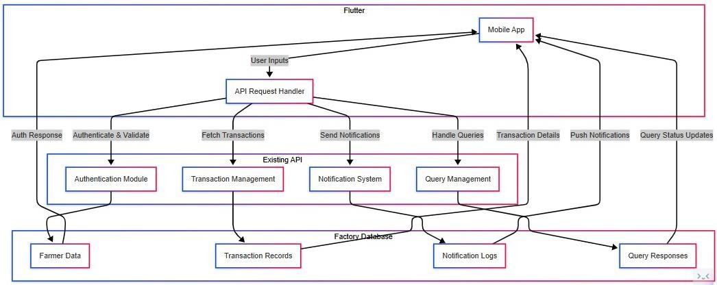

Fig. 4.1 System Architecture

Farmer Module (Flutter App)

    - The mobile application is the primary interface for farmers.
    - It allows farmers to log in, track transactions, receive notifications, and submit queries to the factory.
    - Uses REST API requests to interact with the backend.

Functions:

      - User authentication and role-based access
      - Fetching real-time payment and transaction history
      - Receiving instant notifications on dues, payments, and factory announcements
      - Submitting and tracking queries

Backend (Existing API Interface)

    - The system communicates with the sugar factory’s backend API, which handles all business logic and database interactions.
    - It ensures secure data transfer between the factory and the mobile app.

Subcomponents:

      - Authentication Module → Verifies farmers and grants access to their data.
      - Transaction Management → Fetches and updates payment history and dues.
      - Notification System → Sends real-time alerts for transactions, payments, and announcements.
      - Query Management → Handles farmer queries and retrieves factory responses.

Factory Database

    - The core data storage system of the sugar factory, managed by the backend API.
    - Stores all transactional, authentication, and query related data securely.

Subcomponents:

      - Farmer Data → Stores registration details and role-based access control.
      - Transaction Records → Keeps a real-time log of farmer payments, dues, and bonuses.
      - Notification Logs → Maintains a record of sent notifications and alerts.
      - Query Responses → Stores and tracks queries submitted by farmers and their resolutions.

Why This Architecture?

    - Realtime Data Sync → No outdated records; all info is fetched live from the factory.
    - API Based Efficiency → No need for separate backend development, reducing redundancy.

    - Secure & Scalable → Data is encrypted and accessed via role-based authentication.
    - User-friendly → Farmers get quick access to payments, queries, and notifications 1. Farmer

Data Flow Diagram

Level 0: Context Diagram
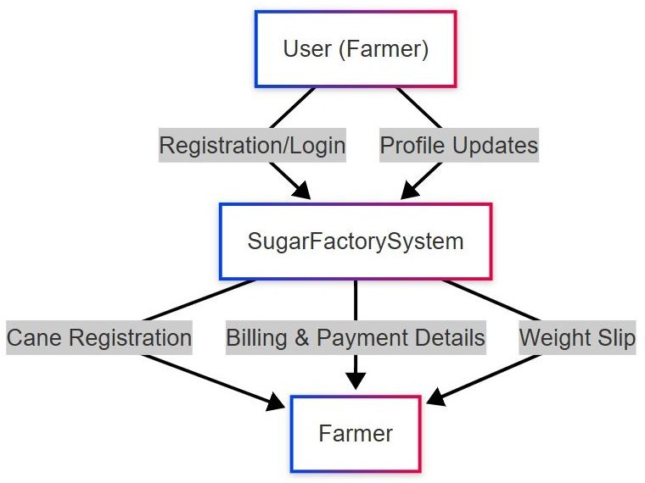

Fig. 4.2. Sugar Factory Data Flow Diagram

User (Farmer)
- The primary user of the system, interacting with the Sugar Factory System via the mobile app.
- Farmers can register, log in, update their profiles, check payment details, submit queries, and receive real-time notifications.

Sugar Factory System (Backend API)
- The central system that processes all farmer related requests.
- Connected to the factory’s existing API, allowing real-time data updates.

Cane Registration & Weight Slip
- Farmers register their sugarcane produce with the factory.

- The system generates a digital weight slip, which provides accurate records of sugarcane delivered.

Billing & Payment Details
- Farmers can view their payment history, including dues and processed transactions.
- The backend retrieves real-time payment status using the factory’s API.

Level 1: Farmer Process Flow
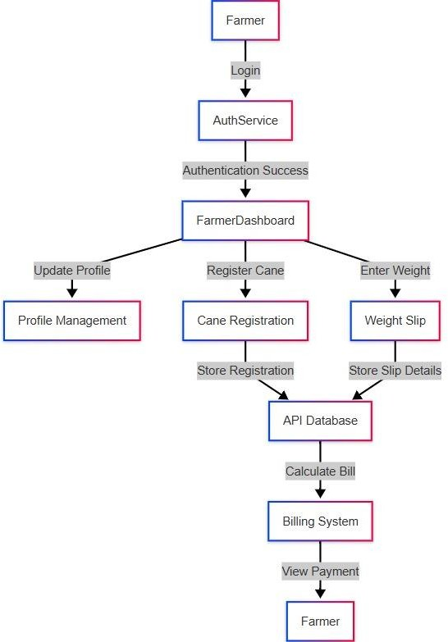

Fig. 4.3. Farmer’s Data Flow Diagram

Farmer: The primary user of the system. Accesses the system via a mobile app or web portal.

Authentication Service: Handles farmer login and authentication. Verifies credentials before granting access to the system. Uses role-based access control to ensure security.

Farmer Dashboard:

The central interface where farmers interact with various functionalities. Farmers can:
- Update Profile
- Register Cane
- Enter Weight Details

Profile Management: Allows farmers to update personal details like contact info and bank details. Ensures data consistency across the system.
Cane Registration: Farmers register their sugarcane deliveries with the factory. The system captures important data like the date, quantity, and farm location.
Weight Slip: Farmers enter the weight of their sugarcane after delivery. The system generates a digital weight slip for reference.
API Database: The core backend storage system that interacts with the factory’s existing API. Stores registration details, weight slip data, and payment records. Ensures real-time access to factory data.
Billing System: Retrieves data from the API database to calculate the farmer’s earnings. Computes payments based on weight, sugarcane quality, and factory pricing. Sends billing information to the farmer’s dashboard.
Payment View (Farmer Receives Payment Info): Displays processed payment details to the farmer. Provides real-time updates on payment status and transaction history.

Level 2: Farmer Cane Registration Flow
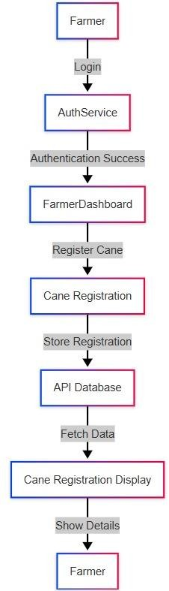

Fig. 4.4. Farmer’s Cane Registration Flow Diagram

Farmer: The user (farmer) who interacts with the system. Starts the process by logging in.

Authentication Service: Verifies the farmer's login credentials. Ensures secure access to the system.

Farmer-Dashboard: The main interface where farmers access different functionalities. Provides access to registering cane and viewing details.
Cane Registration: Farmers enter details of their sugarcane delivery, including: Cane quantity, Date of delivery, Farm location
API Database: Stores the cane registration details. Provides real-time access for farmers to check their deliveries.
Cane Registration Display: Retrieves and displays the stored cane registration details. Farmers can view: Submitted data, Delivery status.
Final Step: Farmer Views Details: The farmer sees their cane registration records on the app. Confirms that the data is correctly stored and displayed.

Entity Relationship Diagrams
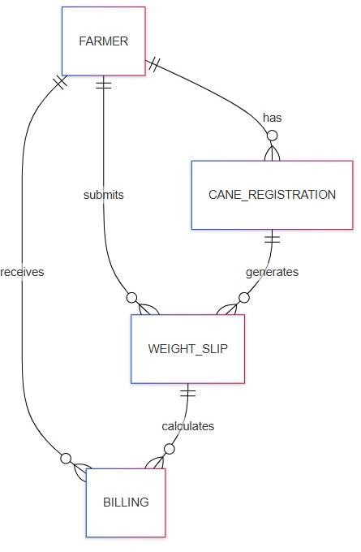

Fig. 4.5. Farmer Module ER Diagram

FARMER (Main Entity)

- Represents farmers who register their sugarcane, submit weight details, and receive payments.
- Each farmer has a unique farmer_id and details like name, mobile number, Aadhaar, PAN, and bank details.
- Relationships:

Has → Cane Registration Submits → Weight Slip Receives → Billing

CANE_REGISTRATION (Sugarcane Entry)

- Captures details when a farmer registers their sugarcane for processing.
- Includes attributes like registration ID, cane type, group, village, water source, planting date, and land area.
- Relationship:

Has → Linked to a farmer.

Generates → Weight Slip for the registered cane.

WEIGHT_SLIP (Cane Weighing Process)

- Generated after cane registration, this records the weight and transport details of the cane.
- Attributes include slip ID, cane weight, vehicle type, cutting method, and slip date.
- Relationships:

Submits → Farmer submits a weight slip. Generates → Derived from Cane Registration. Calculates → Billing is based on this.

BILLING (Farmer's Payment Calculation)

- Represents the payment details for the sugarcane supplied.
- Stores values like bill ID, cane weight, rate per ton, total amount, deductions, and net amount.
- Relationships:

Receives → Farmer receives the bill.

Calculates → Weight Slip is used to compute the final bill.

UML Diagrams

Use Case Diagram
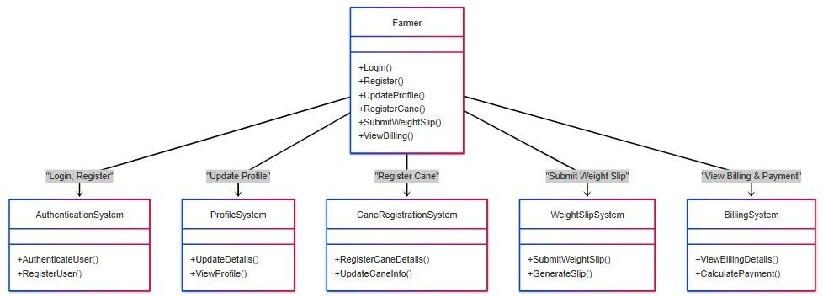

Fig. 4.6 Farmer Use case Diagram

Farmer (Main Entity)
- The Farmer interacts with the system to perform various activities like logging in, registering cane, updating their profile, submitting weight slips, and viewing billing details.

Authentication System
- Manages farmer login and registration.
- Ensures that only authenticated users can access the system.

Profile System
- Allows farmers to update and view their profile details, such as personal information and bank details.

Cane Registration System
- Handles sugarcane registration, including details like crop type, land area, and village.
- Farmers can also update cane-related details.

Weight Slip System
- Farmers submit weight slips after delivering cane.
- The system stores and processes weight slip details for billing calculations.

Billing System
- Calculates payment based on cane weight and rate per ton.
- Farmers can view their total payment, deductions, and net amount.

Class Diagram

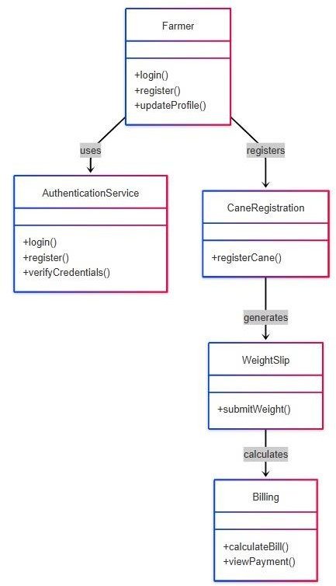

Fig. 4.7. Sugar Factory App Class Diagram

Farmer (Main Entity)

  - The Farmer is the central entity that interacts with different systems. Attributes may include farmer_id, name, mobile, aadhaar, bank_details, etc.

Authentication System

  - Manages farmer login and registration. Ensures secure access to the system.

Profile System

  - Allows the farmer to update personal details like contact, bank information, etc.

Cane Registration System

  - Enables farmers to register their sugarcane for processing. Stores details like cane_type, land_area, planting_date.

Weight Slip System

  - Farmers submit weight slips after delivering the cane. Includes attributes like cane_weight, vehicle_type, and slip_date.

Billing System

  - Calculates payments based on submitted weight slips. Computes total amount, rate per ton, deductions, and net amount. Allows farmers to view billing details

System Flow:

- Farmer Logs In/Register → Uses AuthenticationSystem.

- Updates Profile (Optional) → Uses ProfileSystem.

- Registers Cane → Uses CaneRegistrationSystem.

- Submits Weight Slip → Processed in WeightSlipSystem.

- View Billing & Payments → Uses BillingSystem.

Activity Diagram

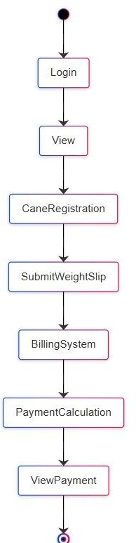

Fig. 4.8 User Activity Diagram

Steps:
- Start Node: The process begins with the farmer interacting with the system.
- Login: The farmer logs into the system using credentials (username/password or other authentication methods).
- View: After successful login, the farmer can view available options in the dashboard.
- Cane Registration: The farmer registers the sugarcane details, including type, land area, and planting date.
- Submit Weight Slip: After harvesting, the farmer submits the weight slip, which contains details about the quantity of sugarcane delivered.
- Billing System: The system processes the weight slip and generates a bill based on the cane weight and predefined rates.
- Payment Calculation: The system calculates the total payment, applying rates per ton and deductions, if any.
- View Payment: The farmer can view the final payment details, including total earnings and deductions.
- End Node: The process concludes.

Component Diagram

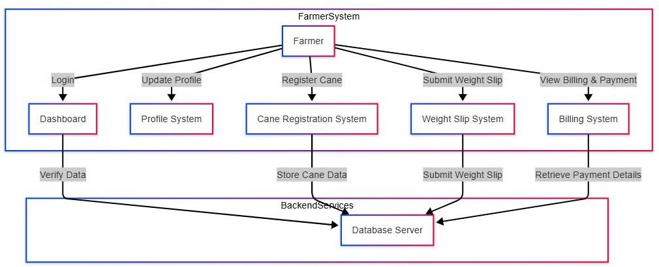

Fig. 4.9 Sugar Factory App Component Diagram

The component diagram represents the major functional parts of the Farmer Cane Registration & Payment System and how they interact. It is divided into two main sections: Farmer System (Frontend Components), Backend Services (Database Processing)

Farmer System (Frontend Components)
This part of the system includes all the functionalities that a farmer interacts with:
  - Farmer (User): The farmer is the primary user of the system. Can log in, update their profile, view their sugarcane, submit weight slips, and view payments.
  - Authentication System: Handles login of farmers. Verifies credentials with the Database Server.
  - Profile System: Farmers can update their personal details, including: Name, Aadhaar Number, Bank Details
  - Cane Registration System: Farmers register their sugarcane crops with details like: Type of cane, Land area, Plantation date. The data is stored in the Database Server.
  - Weight Slip System: Farmers submit weight slips after harvesting. Stores data like: Cane weight, cutting method, Slip date
  - Billing System: Retrieves the weight slip data from the database. Calculates the total payment based on: Cane weight, Rate per ton, Deductions. Displays the final net payment to the farmer.

Backend Services (Database & Payment Processing)

These components work behind the scenes to store and process data.

    - Database Server: Stores all the information about: Farmers, Cane registrations, Weight slips, Payment transactions. Used by different modules to fetch and update data.

Chapter 5 Algorithm

ALGORITHMS

1. Algorithms

The Sugar Factory Application involves several processes that require algorithms for handling data efficiently, automating calculations, managing notifications, and ensuring secure access.

Farmer Payment Management Algorithm Purpose:
The Farmer Payment Management Algorithm is designed to track payments made to farmers for their crop deliveries, ensuring that each payment is calculated accurately, tracked throughout its lifecycle, and communicated effectively to farmers.

Detailed Algorithm Steps:

Calculate the Amount Owed to the Farmer:

Input: After the farmer delivers their crop (e.g., sugarcane), the system receives the total weight of the crop delivered.

Process:

- Fetch the rate per ton of the crop from the database (based on predefined rates for sugarcane).
- Calculate the total payment owed to the farmer:
Total Payment = Cane Weight Delivered (tons) - Rate per Ton (₹)
- Deduct applicable charges, if any (e.g., transportation fees, quality penalties, government taxes).
Net Payment = Total Payment - Deductions

Output: The calculated net payment amount is stored in the farmer's transaction history in the database.

Track the Payment Process:

Input: Once the payment calculation is complete, the system begins the payment process by interacting with an external payment gateway (e.g., Razor pays, Stripe).

Process:

- The system initiates the payment and sets the status to Initiated.
- Update the database with the payment status as:
  - Initiated: Payment has been requested.
  - Processing: Payment is being processed by the payment gateway.
  - Completed: Payment has been successfully completed.
  - Failed: Payment has failed, and further action is required.
- During this stage, the payment system regularly checks with the payment gateway to track the real-time status.

Notify the Farmer and Update Transaction History:

Input: Once the payment status is updated to Completed, the system proceeds to notify the farmer.

Process:

- The notification contains details such as the payment amount, payment date, and transaction ID.
- Update the transaction history in the farmer’s profile to reflect the payment:
  - Transaction ID
  - Amount paid
  - Payment date
  - Status (completed)

Output: The farmer is alerted about the payment, and their transaction history is updated with all relevant information.

Chapter 6 Project Implementation

PROJECT IMLEMENTATION

Project Steps
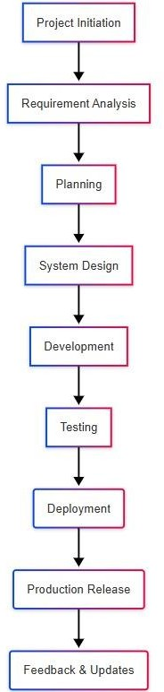

Fig. 6.1. Project Steps Diagram

Project Initiation

Goal: Understand the problem and define objectives.

Functional Requirements:

    - Identify the core problem (helping farmers register cane and receive payments digitally).
    - Define target users: Farmers, Sugar Factory, Admin.
    - Conduct market research to identify existing solutions and gaps.
    - Set up an initial project scope and define key features.

Requirement Analysis

Goal: Collect functional and technical requirements.

Functional Requirements:

    - Farmer registration & login
    - Cane registration & weight slip submission
    - Billing & payment calculation
    - Notifications & report generation

Non-functional Requirements:

    - Security (role-based access, authentication)
    - Performance (fast response time for transactions)
    - Scalability (support for multiple farmers & factories)
    - Identify required API endpoints and database entities.

Planning

Goal: Decide on the technology stack and create a project roadmap.

    - Choose the technology stack: Frontend (Flutter (Dart)), Backend (Dart with REST APIs), Database (MySQL), Authentication: (Role-based access)
    - Define the project timeline with milestones.
    - Assign responsibilities to developers, testers, and designers.

System Design

Goal: Create architectural diagrams and wireframes.

    - Database Design: Create an ER diagram for tables like Farmer, Cane_Registration, Weight_Slip, and Billing.
    - Class Diagram: Define relationships between frontend and backend components.
    - Flowcharts: Visualize the login, weight submission, and payment processes.
    - UI Wireframes: Design an intuitive mobile app interface for farmers.

Development Phase

Goal: Start coding the frontend, backend, and database.

Frontend Development (Flutter)

    - Build registration, login, and dashboard UI.
    - Implement navigation between modules (Cane Registration, Billing, etc.).

Backend Development (Dart & API Integration)

    - Develop APIs for authentication, weight slip submission, and billing.
    - Connect the backend with the MySQL database.
    - Implement business logic for payment calculations.

Database Setup (MySQL)

    - Create tables for farmers, transactions, and billing.
    - Store data securely using indexes and optimized queries.

API & Authentication Integration

    - Implement secure login with JWT authentication.
    - Handle data retrieval and updates between the frontend and backend.

Testing

Goal: Identify and fix bugs before deployment.

  - Unit Testing: Test individual modules (e.g., login, payment calculations).
  - Integration Testing: Ensure smooth interaction between the frontend, backend, and database.
  - System Testing: Check overall performance and security of the system.
  - User Acceptance Testing: Get feedback from farmers and factory staff.

Deployment

Goal: Launch the system for real users.

  - Deploy the backend API on a cloud server (AWS, Firebase, or Digital Ocean).
  - Publish the Flutter app on the Google Play Store.
  - Set up data backups and monitoring tools.

Production Release

Goal: Ensure smooth operations after deployment.

  - Monitor server uptime and app performance.
  - Fix any real-time issues reported by farmers.
  - Ensure secure and timely payment processing.

Feedback & Updates

Goal: Continuously improve the system based on user feedback.

  - Collect feedback from farmers and factory managers.
  - Release updates with bug fixes and performance improvements.
  - Add new features like AI-based crop prediction and SMS notifications.

Working model of proposed system

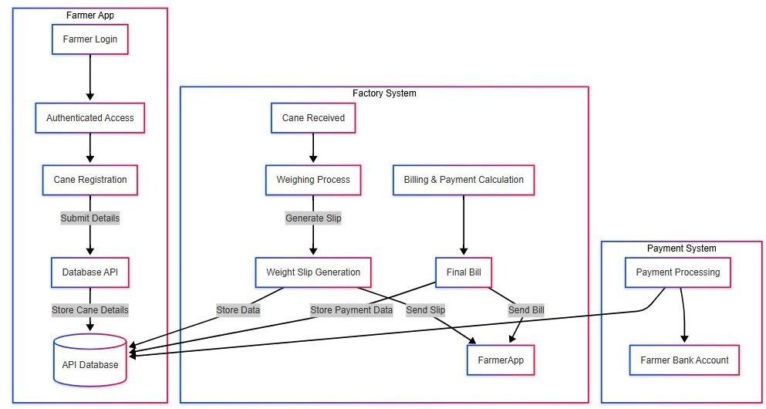

Fig. 6.2 System Working Model

Farmer Registration & Authentication

- Farmers create an account via the mobile app by entering: Name, Mobile Number, Aadhaar ID, Land Details
- After successful authentication, the farmer gains access to the system.
- Farmer details are stored in the MySQL database via API.

Cane Registration & Submission

- Farmers register their sugarcane details, including: Cane variety, estimated weight, Expected delivery date
- The system validates the details and stores them in the database.

Cane Delivery & Weight Slip Generation

- The farmer delivers the sugarcane to the factory.
- The weighing machine records the actual weight of the delivered cane.
- The system compares the estimated and actual weight.
- A weight slip is generated and stored in the database.
- Farmers receive a digital weight slip in the app.

Billing & Payment Calculation

- The system calculates the final bill using:
Weight × Price per Ton
- Bonuses, incentives, and deductions (if applicable)
- The final bill is generated and displayed to the farmer.
- The billing details are stored in MySQL.

Payment Processing & Settlement

- The transaction details are updated in the system.

RealTime Data Updates

Farmers receive instant updates on:

- Cane registration status
- Weight slip generation
- Billing details
- Payment completion

The system ensures seamless data flow between farmers and the factory.

Chapter 7 Software Testing

SOFTWARE TESTING

Software Testing

Testing is essential to ensure that the Farmer Cane Registration & Payment System functions correctly, meets requirements, and provides a seamless experience for farmers. Various software testing methodologies are used, including functional, nonfunctional, and security testing.

Functional Testing

  - Functional testing verifies that the system features work as expected.

Unit Testing

  - Purpose: Tests individual functions and components of the system.
  - Tools: JUnit (for backend), Mockito (for API testing).
  - Examples: Checking if cane registration details are stored correctly.

Integration Testing

  - Purpose: Ensures modules interact properly, such as the mobile app, API, and database.
  - Tools: Postman (for API testing), Selenium (for UI testing).
  - Examples: Verifying the data flow between the mobile app and the backend API. Ensuring that the billing system correctly retrieves weight slip details.

System Testing

  - Purpose: Tests the entire system.
  - Tools: Manual testing, Selenium for automation.
  - Examples: Ensuring that a farmer can register, submit cane details, and receive payments successfully. Checking role-based access (farmers vs. factory operators).

User Acceptance Testing (UAT)

  - Purpose: Confirms that the system meets business requirements and is usable by real farmers.
  - Tools: Manual testing, feedback from actual users.

  - Examples: Farmers verify whether cane registration, weight slip, and payment processes are clear. Ensuring the app's language and UI are easy to understand.

Non-Functional Testing

  - Ensures system performance, usability, and security.

Performance Testing

  - Purpose: Ensures the system handles expected loads without lag.
  - Tools: JMeter, LoadRunner.
  - Examples: Testing API response time when multiple farmers submit cane details simultaneously. Checking database performance when processing 1000+ transactions.

Security Testing

  - Purpose: Prevents unauthorized access, data leaks, and fraud.
  - Tools: OWASP ZAP, Burp Suite.
  - Examples: Preventing SQL injection when submitting registration forms.

Usability Testing

  - Purpose: Ensures the app is easy to use for farmers.
  - Tools: Manual user feedback, A/B testing.
  - Examples: Testing whether illiterate farmers can easily navigate the system. Checking if buttons are clear and accessible.

Compatibility Testing

  - Purpose: Ensures the app works on different devices and platforms.
  - Tools: Browser Stack, Device Farms.
  - Examples: Testing on Android and iOS devices. Checking if the app runs on older phones with low RAM.

Regression Testing

  - Purpose: Ensures new updates do not break existing features.
  - Tools: Selenium, TestNG.
  - Examples: Ensuring a new feature (like bank integration) does not break the weight slip feature.

Chapter 8 Result

RESULT



Fig. 8.1. Index Page Fig. 8.2. Login Page
Index page displays Factory Logo. Login page for farmer using Mobile No.

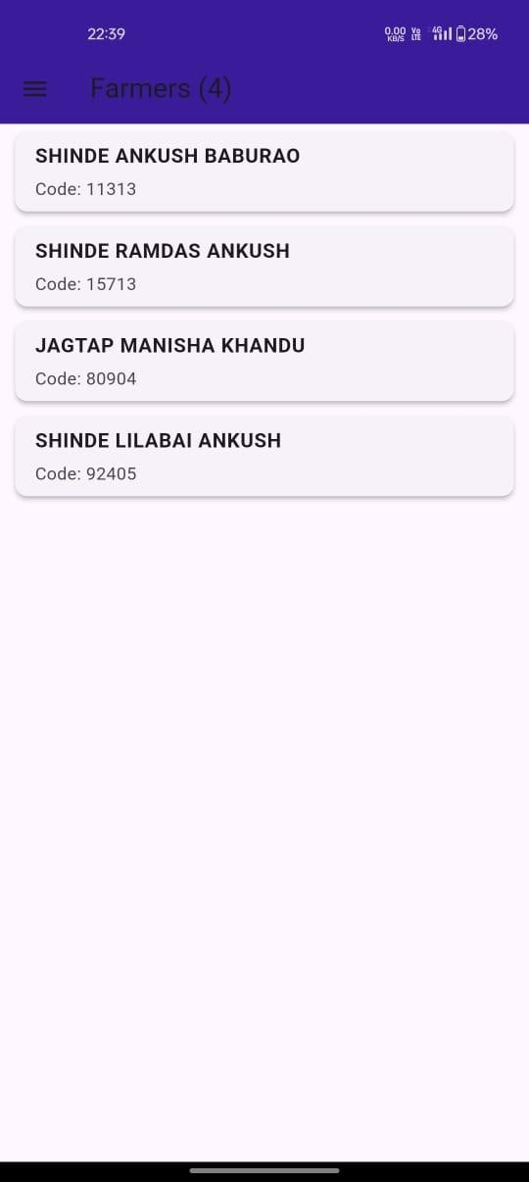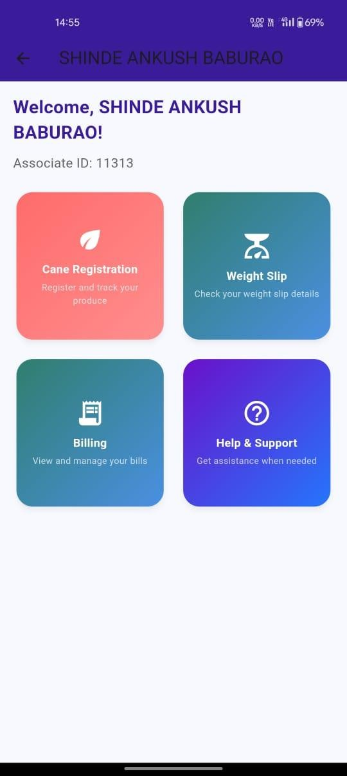

Fig. 8.3. Farmers List Fig. 8.4. Farmers Dashboard
On login, app displays the farmers list that are Farmer Dashboard for displaying various registerd on that mobile no. details as Cane Registration, Weight Slip and
Billing.

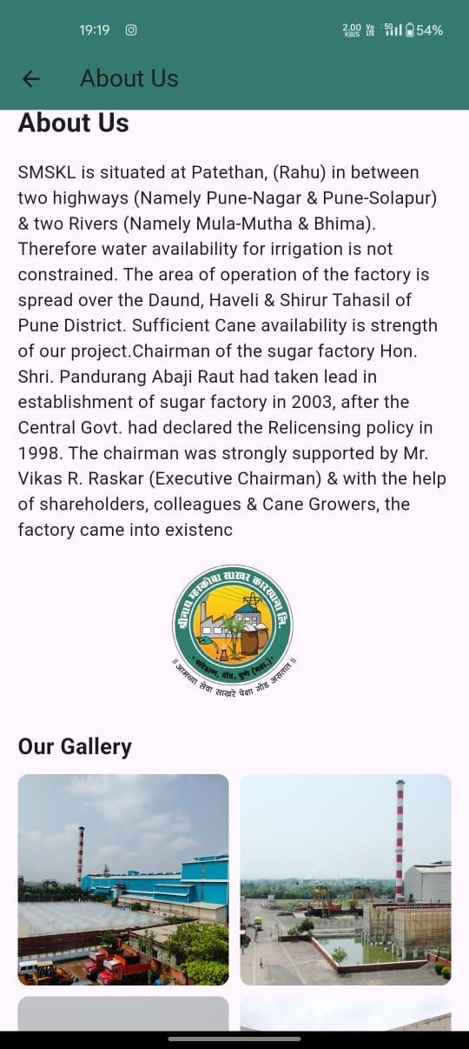

Fig. 8.5 Farmer Profile Fig. 8.6 About Us
Farmer profile displaying associate ID, Factory detail displaying on About us page, Factory’s about us and contact us also some image gallery of the factory

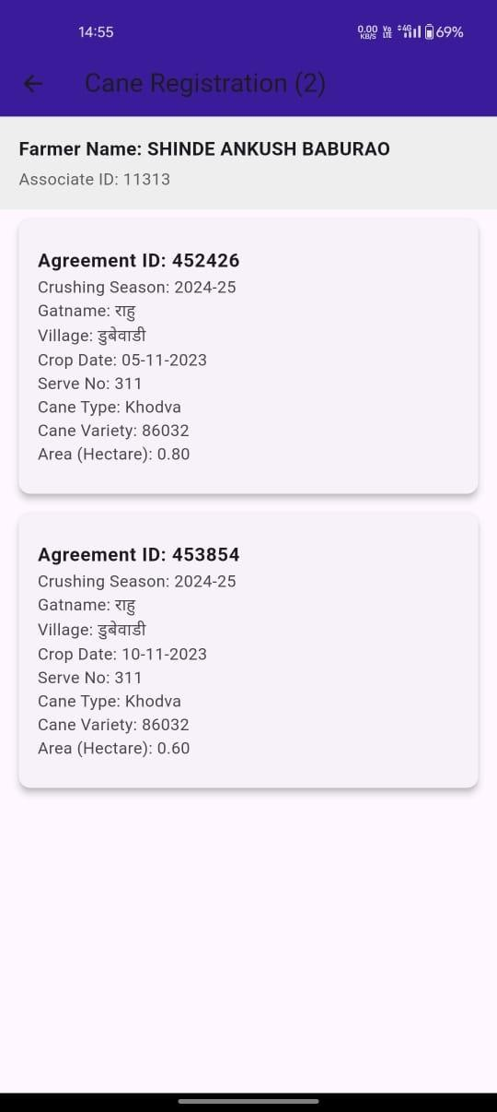

Fig. 8.7. Contact Us Fig. 8.8. Cane Registration
Factory Detail like Email, Phone & Address. Cane Registration form details display.

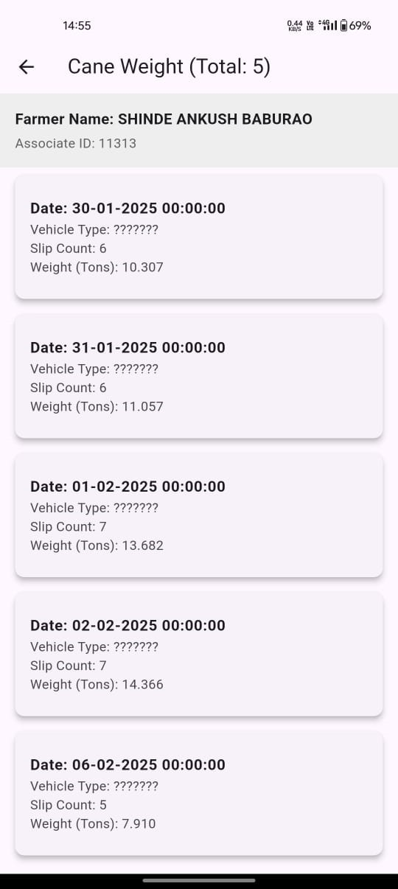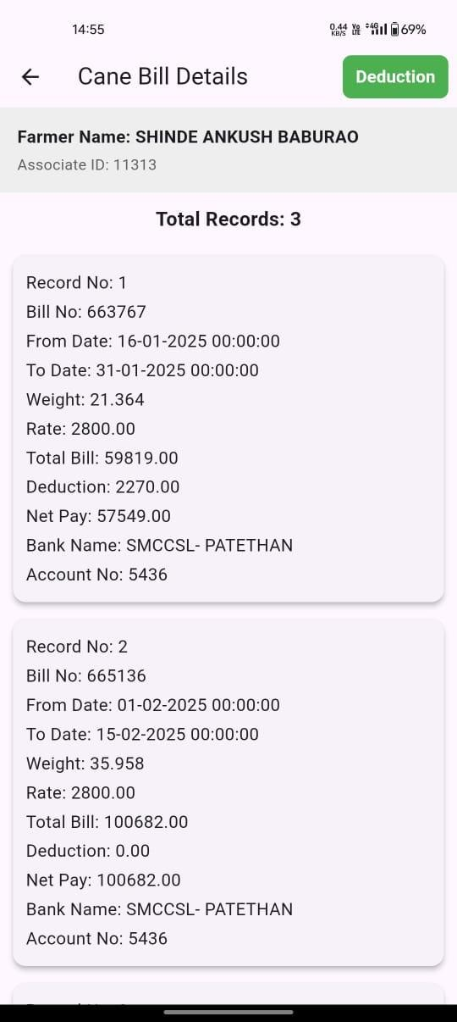

Fig. 8.9. Cane Weight Fig. 8.10. Cane Bill Detials
Cane weight for vehicles displaying slip. Cane bill details for farmers.

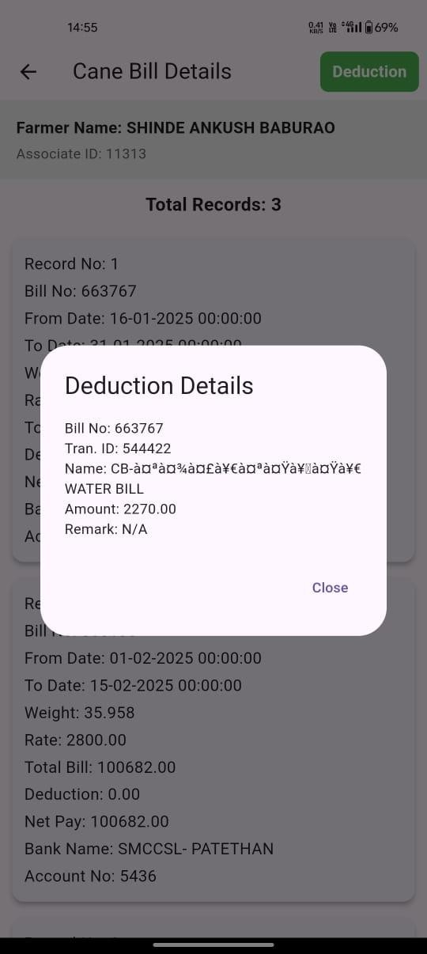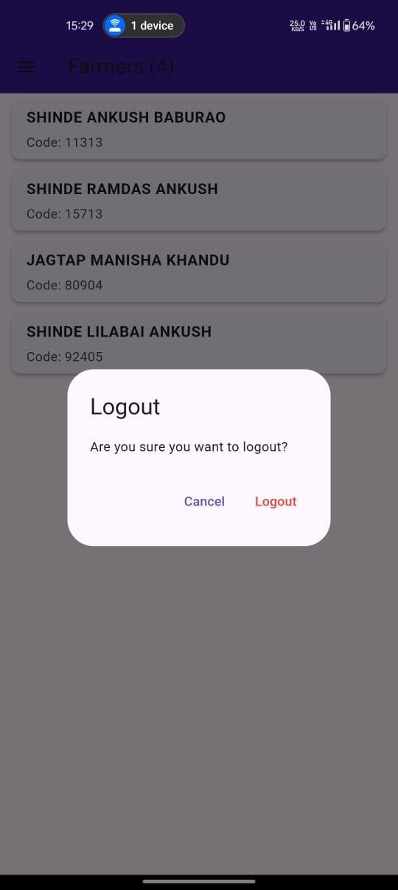

Fig. 8.11. Cane Bill Deduction Fig. 8.12. Logout Page
Displays the deduction in bill as per bill no. Logout page for farmer.

Chapter 9 Advantages & Disadvantages

ADVANTAGES & DISADVANTAGES

Advantages

  - Realtime Data and Updates: Farmers, shareholders, and admins benefit from real-time data synchronization. For instance, farmers can instantly see updates on cane registration approvals, billing information, and payment statuses. This reduces delays and improves operational efficiency.
  - Automated Payment Tracking: Farmers no longer need to manually track payments. The application tracks the status of payments (initiated, processing, completed) and sends notifications when the payment process is complete, streamlining financial management for both the factory and the farmers.
  - User-friendly Dashboard: The app offers user-friendly dashboards for Farmers, Shareholders, and Admins, allowing them to manage their respective operations (cane registrations, payments, dividends, etc.) with minimal technical skills.
  - Offline Functionality: The app’s ability to function in offline mode ensures that farmers in rural areas can still register cane or submit weight slips without requiring continuous internet connectivity. Data is synced when connectivity is restored, ensuring that the user experience is seamless.
  - Cross Platform Support (Android and iOS): The use of Flutter ensures that the application runs smoothly across both Android and iOS platforms, enabling access to a wider range of users.
  - Notifications and Alerts: Realtime notifications through Firebase Cloud Messaging (FCM) ensure that users stay informed about important updates like cane registration approvals, payment status, dividend distributions, and more.
  - Scalability: Firebase’s backend services (Authentication, Firestore, Cloud Functions, and Cloud Messaging) automatically scale based on user load, allowing the system to accommodate increasing numbers of users without significant architectural changes.
  - Secure Authentication and Role Based Access: Firebase Authentication provides secure login and registration mechanisms. Role based access control (RBAC) ensures that each user

(Farmer, Shareholder, Admin) only has access to the features relevant to their role, providing data security and reducing risks of unauthorized access.

Disadvantages

  - Internet Dependency for Critical Features: Although the app supports offline data entry, critical features such as billing, payment processing, and real-time notifications depend on an active internet connection. This could be a disadvantage for users in rural areas with poor connectivity.
  - Higher Costs as the System Scales: Firebase is an excellent choice for a scalable backend service, but as the system grows, costs can increase due to storage, read/write operations, and real-time database usage. Migrating to a paid plan will be necessary to support high traffic and usage.
  - Potential Latency in Remote Areas: Farmers in rural or remote locations with weak internet connections may experience latency in data synchronization or notification delivery. This may result in delays in updating payment statuses or receiving notifications about cane registration approvals.
  - Reliance on Third-party Payment Gateway: The system is dependent on third party payment gateways (like Razor pay, Stripe) for payment processing. If these services experience downtime or technical issues, payments could be delayed, which might lead to dissatisfaction among farmers and shareholders.
  - Security Risks: Handling sensitive data like Aadhaar numbers, PAN details, and bank account information comes with inherent security risks. If there are any vulnerabilities in the system (such as inadequate encryption or weak authentication), it could lead to data breaches, resulting in loss of trust and possible legal repercussions.
  - Customization Challenges: Customization for specific user groups, particularly for regional languages and local cultural nuances, may require more effort. Not all translations and interfaces may be easily adaptable for diverse user bases in rural areas.
  - Learning Curve for Nanotech Savvy Users: Although designed to be user-friendly, farmers or shareholders who are not accustomed to using mobile apps might initially struggle with the system. Additional training and onboarding might be required to ensure proper usage.

Chapter 10 Conclusion & Future Scope

CONCLUSIONS & FUTURE SCOPE

Conclusion

The Farmer Cane Registration & Payment System successfully digitalizes and automates key processes such as cane registration, weight slip generation, and farmer payments, ensuring transparency, efficiency, and accuracy. By integrating the system with the existing API interface used by the factory, we have enabled seamless data exchange and real-time updates, reducing manual errors and delays.
This system enhances the farmer’s experience by simplifying payment tracking and ensuring fair transactions, while also helping sugar factories streamline operations and manage resources effectively. The modular approach of this project allows for future scalability, making it adaptable for further improvements, such as adding a Shareholder Module, AI driven analytics, blockchain secured transactions, and Io based predictive maintenance.
With continuous advancements, this system has the potential to evolve into a comprehensive, smart sugarcane management platform that benefits farmers, shareholders, and factory stakeholders, contributing to a more efficient and sustainable sugar industry.

Future Scope

The Farmer Cane Registration & Payment System has been successfully implemented with the Farmer Module, enabling seamless cane registration, weight slip generation, and billing. However, there is significant potential to enhance the system by adding new modules and functionalities to benefit farmers, shareholders, and factory operations.

Inclusion of Shareholder Module

Currently, the system only supports farmers. By incorporating a Shareholder Module, we can provide transparency and better financial management for sugar factory investors. Which will include investment tracking, dividend management, factory performance analytics, voting & decision-making

AI-Based Cane Yield Prediction & Farmer Advisory

By integrating AI and Machine Learning, we can assist farmers in improving sugarcane production. Which include features like Cane Growth Prediction, Smart Farming Advice, Price Forecasting.

Blockchain Based Payment & Ledger System

To ensure secure and transparent financial transactions, we can implement Blockchain technology. Includes Blockchain Features: Tamper-Proof Payments, Smart Contracts, Fraud Prevention

Multi-Language & Voice Assistance for Farmers

Since many farmers may not be tech-savvy, adding a multilanguage and voice enabled system can improve accessibility. Including features such as Language Support, Voice Based Navigation, SMS & WhatsApp Integration

RealTime GPS Tracking for Cane Transport

To optimize cane transportation and logistics, GPS tracking can be added. Also, we can combine features such as Live Tracking of Cane Deliveries, Optimal Route Suggestions, Alerts & Notifications

References

REFERENCE

- Piangor Loahavilai, Nopasit Chakpitak, Thunyaporn Jaimung (2017) Human Asset Management at the End-of-Life Phase” 11th International Conference on Software, Knowledge, Information Management and Applications (SKIMA) https://ieeexplore.ieee.org/document/8294115
- Ahmed, Abdella. (2024). DETERMINANT OF LABOR SUPPLY IN METEHARA SUGAR FACTORY CASE STUDY ON METEHARA SUGAR FACTORY. doi:10.13140/RG.2.2.34625.36962.
https://www.researchgate.net/publication/382967793_DETERMINANT_OF_LABOR_SUPP LY_IN_METEHARA_SUGAR_FACTORY_CASE_STUDY_ON_METEHARA_SUGAR_ FACTORY
- Yang, N. (2010). In Paper “Research on Integrated Design Platform of Sugarcane Harvester.” 2010 International Conference on Measuring Technology and Mechatronics Automation.
https://ieeexplore.ieee.org/document/5459578

- S. K. Gupta and A. P. Agarwal, "Predicting Total Sugar Production Using Multivariable Linear Regression," 2021 International Conference on Computing, Communication, and Intelligent Systems (ICCCIS), Greater Noida, India, 2021, pp. 465469, doi: 10.1109/ICCCIS51004.2021.9397078.
https://ieeexplore.ieee.org/document/9397078

- Singh, H., & Singh, R. K. (2020). Irrigation and fertigation scheduling effect on phenology and yield of spring sugarcane (Sachharum officinarum). The Indian Journal of Agricultural Sciences, 90(6), 10541057.
https://epubs.icar.org.in/index.php/IJAgS/article/view/104753

- S. Thuankaewsing, S. Pathumnakul and K. Piewthongngam, "Using an artificial neural network and a mathematical model for sugarcane harvesting scheduling," 2011 IEEE

International Conference on Industrial Engineering and Engineering Management, Singapore, 2011, pp. 308312, doi: 10.1109/IEEM.2011.6117928.
https://ieeexplore.ieee.org/ stamp/stamp.jsp?tp=&arnumber=6117928&isnumber=6117862

- B. M. Rocha, G. da Silva Vieira, A. U. Fonseca, H. Pedrini, N. M. de Sousa and F. Soares, "Evaluation and Detection of Gaps in Curved Sugarcane Planting Lines in Aerial Images," 2020 IEEE Canadian Conference on Electrical and Computer Engineering (CCECE), London, ON, Canada, 2020, pp. 14, doi: 10.1109/CCECE47787.2020.9255701.
https://ieeexplore.ieee.org /stamp/stamp.jsp?tp=&arnumber=9255701&isnumber=9255669

- D. Murugan and D. Singh, "Development of an Approach for Monitoring Sugarcane Harvested and NonHarvested Conditions Using Time Series Sentinel1 Data," IGARSS 2018 IEEE International Geoscience and Remote Sensing Symposium, Valencia, Spain, 2018, pp. 53085311, doi: 10.1109/IGARSS.2018.8518261.
https: //ieeexplore.ieee.org/document/8518261

- Liang Yu and Luo Yongjun, "A research and practice for sugarcane area's farm management information service platform," 2010 International Conference on Computer Application and System Modeling (ICCASM 2010), Taiyuan, China, 2010, pp. V9218V9221, doi: 10.1109/ICCASM.2010.5623050.
https://ieeexplore.ieee.org/document/5623050

- C. Xu, Z. Jiang, and C. Ma, "Research on Measuring Method of Farmers' Bearing Capacity to Agricultural Water Price," 2010 3rd International Conference on Information Management, Innovation Management and Industrial Engineering, Kunming, China, 2010, pp. 567
https://ieeexplore.ieee.org/document/5694971

- R. Khara, D. Pomendkar, R. Gupta, I. Hingorani, and D. Kalbande, "Micro Loans for Farmers," 2020 11th International Conference on Computing, Communication and

Networking Technologies (ICCCNT), Kharagpur, India, 2020, pp. 15, doi: 10.1109/ICCCNT49239.2020.9225577.
https://ieeexplore.ieee.org/document/9225577

- Z. M. Mie Aung, N. Arunrat, S. Sereenonchai, M. Yuttitham, T. N. Stewart and W. Chaowiwat, "Farmers' Knowledge, Attitude and Practice on Integrated Pest Management in Kalaw Region, Myanmar," 2020 International Conference and Utility Exhibition on Energy, Environment and Climate Change (ICUE), Pattaya, Thailand, 2020, pp. 1-7, doi: 10.1109/ICUE49301.2020.9307118.
https://ieeexplore.ieee.org/document/9307118
- Neelam Labhade-Kumar “Combining Hand-crafted Features and Deep Learning for Automatic Classification of Lung Cancer on CT Scans”, Journal of Artificial Intelligence and Technology, 2023
https://www.researchgate.net/publication/375910086_Combining_Handcrafted_Features_and
_Deep_Learning_for_Automatic_Classification_of_Lung_Cancer_on_CT_Scans
- Neelam Labhade-Kumar “Enhancing Crop Yield Prediction in Precision Agriculture through Sustainable Big Data Analytics and Deep Learning Techniques”, Carpathian Journal of Food Science and Technology,2023, Special Issue, 1-18
https://www.researchgate.net/publication/382448397_ENHANCING_CROP_YIELD_PRED ICTION_IN_PRECISION_AGRICULTURE_THROUGH_SUSTAINABLE_BIG_DATA_ ANALYTICS_AND_DEEP_LEARNING_TECHNIQUES
- Neelam Labhade-Kumar, Study on Object Detection Algorithm, Indian Journal of Technical Education UGC Care Group I, ISSN 0971-3034 Vol47,Special Issue,PP- 14-17,
April 2024
- Neelam Labhade-Kumar “To Study Different Types of Supervised Learning Algorithm” May 2023, International Journal of Advanced Research in Science, Communication and Technology (IJARSCT), Volume 3, Issue 8, May 2023, PP-25-32, ISSN-2581-9429 DOI: 10.48175/IJARSCT-10256
https://ijarsct.co.in/Paper10256.pdf

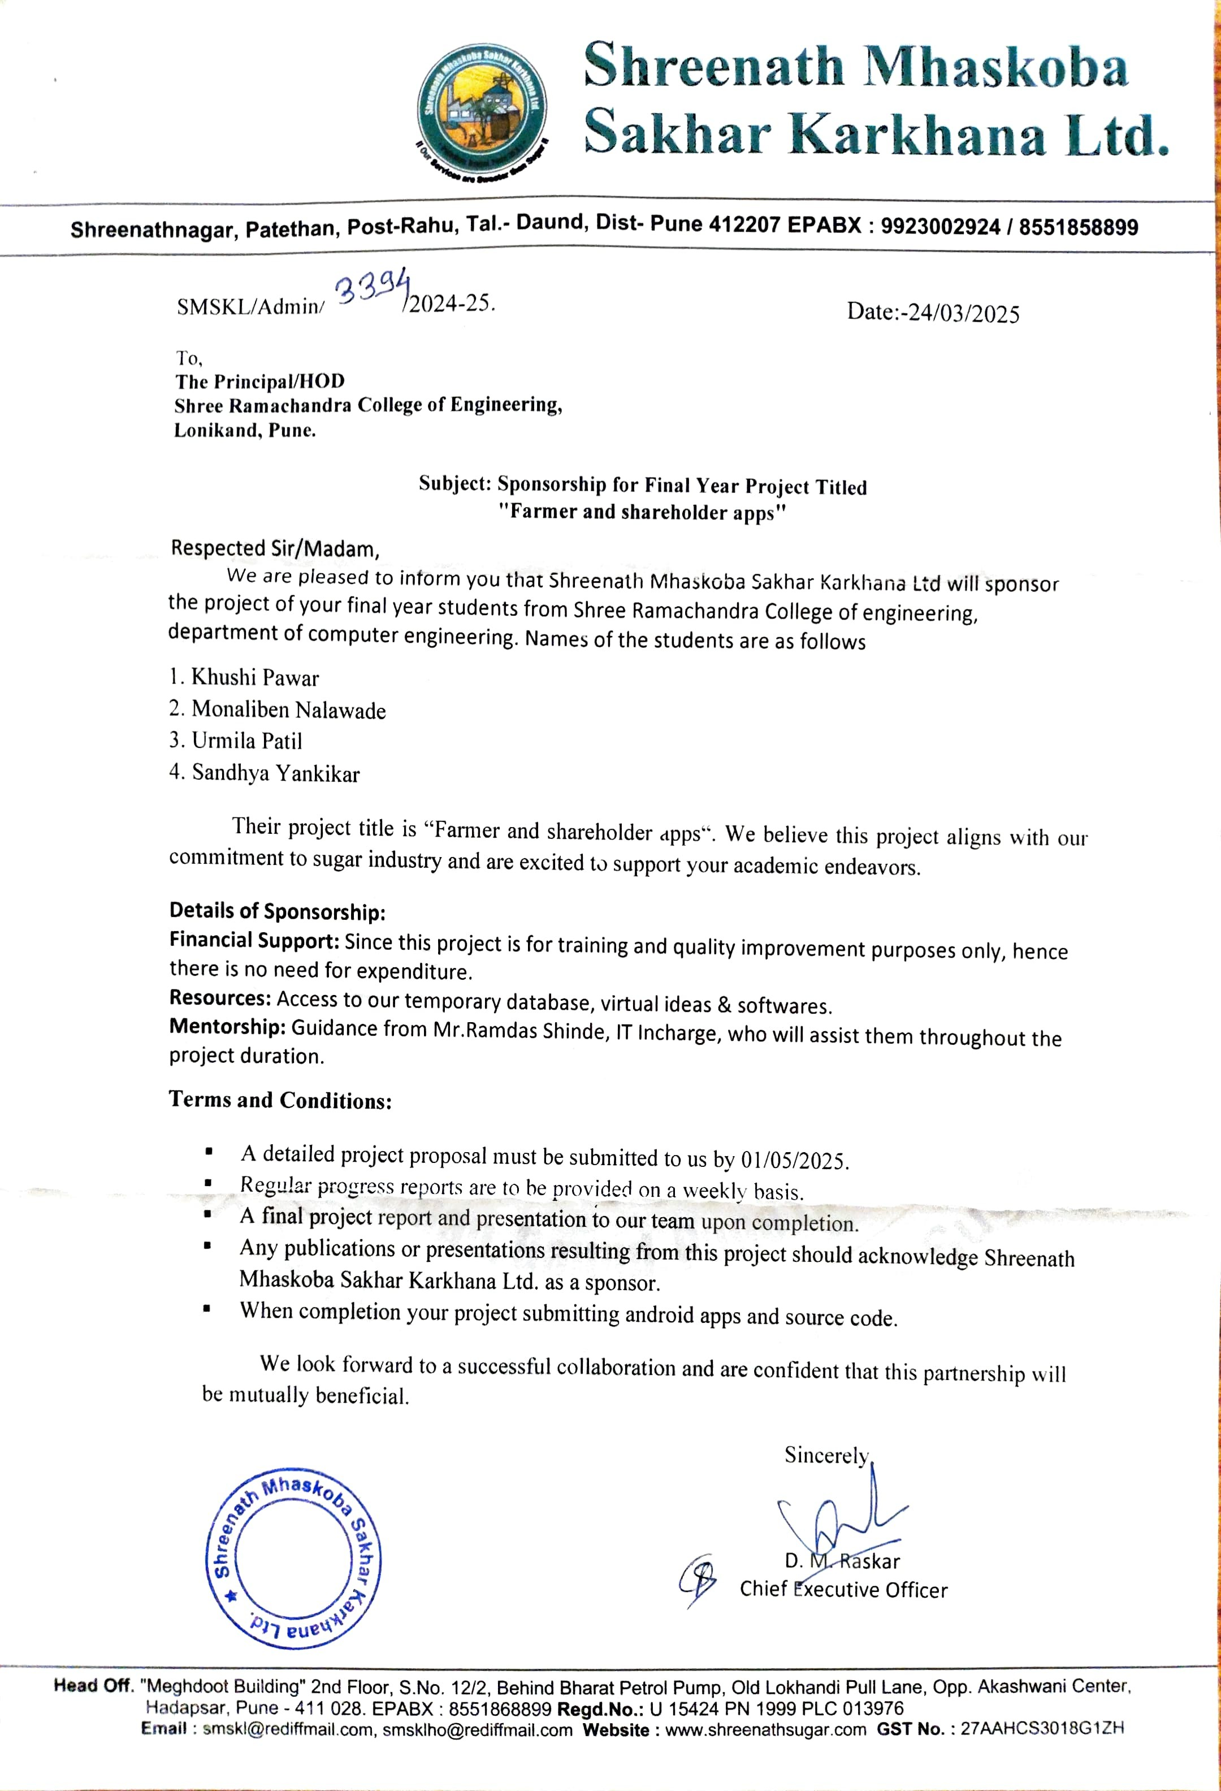

A STUDY OF ALGORITHMS USED IN MOBILE
APPLICATION DEVELOPMENT FOR SUGAR FACTORY
Prof. Dr. Neelam Kumar¹, Monaliben Nalawade², Khushi Pawar³, Urmila Patil⁴, Sandhya Yankikar⁵
¹(Professor, SRCOE, Department of Computer Engineering, Pune)
², ³, ^{,4}, ⁵(Student, SRCOE, Department of Computer Engineering, Pune) Corresponding author: khushipawar.1203@gmail.com

Abstract: Enhancement of transparency, operational efficiency, and user satisfaction have been achieved through the implementation of Farmer Payment Management and Shareholder Analytics & Reporting in the sugar factory's mobile application. Farmers are accurately compensated for their crop deliveries in a timely manner with the help of the Farmer Payment Management Algorithm. By calculating the payment based on crop weight and current rates, applying any necessary deductions, and tracking the payment's status from initiation through completion, the program simplifies what was previously a labour-intensive process. Farmers are informed immediately after payment completion through real-time tracking and automated notifications. Powerful insights into the sugar factory's production and financial metrics have been provided by the Shareholder Analytics & Reporting Algorithm. Key performance indicators, such as peak production times, payment trends, and investment growth rates, are highlighted in comprehensive reports that are generated from the aggregation of data from crop yields, payment records, and investment information. Through visual dashboards, shareholders can see the data in easy-to-read graphs and charts, empowering them to make informed decisions about their investments. More strategic planning and resource allocation can be achieved with the help of these analytics, as they offer a broader view of factory operations. Real-time data synchronization, role-based access, and secure storage of sensitive data are ensured using these algorithms in a highly integrated design platform.
Keywords: Mobile App Development, Farmer Payment Management, Shareholder Analytics & Reporting, User Experience (UX), Real-time Data

- INTRODUCTION
Agricultural industries, especially in growing regions, face complicated challenges related to conversation, monetary transparency, and data accessibility among stakeholders. Farmers, shareholders, and directors are indispensable to the rural manufacturing procedure, yet the glide of statistics among those companies is frequently inefficient. The disconnect between statistics assets, manual financial monitoring, and restrained get right of entry to real-time insights avert efficient decision-making and create delays, impacting productiveness and agree with within agricultural groups. As industries worldwide embrace virtual transformation, the rural area has an opportunity to leverage present day technology to deal with those problems through mobile packages, which can be an increasing number of handy to rural groups. [1]
Effective communique is essential in agricultural settings in which well-timed updates on production, marketplace tendencies, and economic transactions can influence outcomes. but, conventional techniques of facts change, such as in character meetings or paper facts, are slow, at risk of errors, and fail to reach far off regions effectively. The want for digital solutions turns into even greater crucial in conditions where monetary transparency is a concern (inclusive of tracking bills to farmers or managing investments for shareholders). With a mobile based device, stakeholders can access and track crucial records in actual time, thereby minimizing discrepancies and improving overall operational transparency. [4]
Algorithms play an important position in such systems, as they automate complicated workflows, cope with large statistics sets, and ensure that every user’s needs are met via tailor-made functionalities. for example, payment algorithms can make certain farmers receive timely and accurate reimbursement for his or her produce, while analytics algorithms offer shareholders with insights into manufacturing trends and funding performance. by means of using algorithms to manage payments, records analytics, and notifications, mobile packages create an environment where every interplay is effectively monitored and recorded. in this context, examining the

algorithms that underpin agricultural apps is essential to recognize their effect on person experience, operational performance, and transparency. This assessment explores the potential of cellular algorithms designed especially for agricultural applications to transform the control of production, payment, and reporting approaches, thereby supplying a version for digital innovation in the agricultural industry. [5]

- LITERATURE REVIEW
Khara et al. in the paper Micro Loans for Farmers, (2020), propose a blockchain-based solution to address the challenges faced by farmers in obtaining affordable microloans. The authors discuss the limitations of traditional microfinance institutions (MFIs), such as high-interest rates, lengthy loan approval processes, and lack of transparency, which create barriers for low-income farmers. Due to these challenges, farmers often resort to private moneylenders, who impose even higher rates and unsustainable terms. This study proposes a system that utilizes blockchain technology to manage microloans through a decentralized ledger, eliminating intermediaries and reducing loan costs. By using smart contracts, the proposed solution enables low-cost, secure, and real-time transactions, fostering a transparent loan environment. Farmers can broadcast loan requests with specific terms, such as desired interest rates, and investors are able to review farmers' credit scores before lending. The study emphasizes that the transparency and efficiency of blockchain can build trust among stakeholders, thus attracting more small- and large-scale investors. This blockchain-based platform also introduces a unique token system, which allows farmers to utilize the borrowed funds for specific agricultural expenses, thereby ensuring that the funds are not diverted to non-productive uses. Moreover, the envision that this system could offer repayment flexibility by allowing farmers to repay in either currency or harvested crops. This approach not only provides flexibility to farmers but also allows investors to potentially profit from crops sold at market rates. The study concludes that implementing this blockchain solution could enhance financial inclusivity for farmers, reduce dependency on MFIs, and support sustainable agricultural practices in India. [1]
Sai Pradeep K et al. in the paper Analysing Performance of Company through Annual Reports using Text Analytics (2019) proposed that text analytics can be a valuable tool in interpreting the unstructured textual data found in annual reports to evaluate a company's performance. Their research highlights that the textual component, which constitutes about 80% of annual reports, contains essential insights beyond the numerical data typically analyzed by investors. By employing sentiment and emotion analysis, using lexicons like Bing and NRC, the study examined how emotions embedded in these reports (such as positivity, trust, and fear) correlate with a company’s current performance and future returns. The results indicate a significant relationship between the emotions present in annual reports and the company's subsequent market performance, demonstrating that text analytics can aid stakeholders in making data-driven decisions based on both quantitative and qualitative information in annual reports. [2]
Piang-or Loahavilai et al., in the paper Human Asset Management at the End-of-Life Phase (2017), propose a model for managing aging workers in industrial settings by adapting the Reliability Centered Maintenance (RCM) approach. They argue that older workers, despite physical deterioration, accumulate valuable competence over time and should be evaluated as critical human assets rather than simply phased out due to age. The authors introduce a "Reliability Centered Manpower" model, which incorporates factors like performance, competence, and physical capability to assess whether older workers should continue in their roles, be reassigned, or be considered for retirement. This model enables managers to make rational, fair decisions on manpower planning that balances productivity, experience retention, and physical demands on aging employees. [3]
David et al., in the paper The Analysis of Shareholder Theory and Stakeholder Theory (2011), state that the shareholder theory emphasizes maximizing shareholder wealth as the primary purpose of a corporation, while the stakeholder theory advocates for a more balanced approach, considering the interests of all stakeholders, including employees, customers, and the community. Their analysis highlights the ethical and practical implications of each theory, concluding that while shareholder theory aligns with traditional profit-maximization goals, stakeholder theory fosters sustainable development by balancing various interests, potentially benefiting the corporation and society in the long term. [4]
C. Xu et al. in the paper Research on Measuring Method of Farmers' Bearing Capacity to Agricultural Water Price (2010), proposed a method for evaluating farmers’ capacity to bear agricultural water prices. The authors state that understanding farmers' economic affordability and mental endurance is crucial for successful

water price reform and sustainable agricultural practices. Their method includes surveying farmers' water use and willingness to pay, using tools like participatory rural appraisal (PRA) and structured questionnaires. They divided farmers' bearing capacity into two main aspects: economic affordability, which depends on income and production costs, and mental endurance, measured by willingness to pay (WTP) for irrigation. Their framework proposes that economic affordability is best assessed by examining water fees as a percentage of total income, agricultural production costs, and net income. For mental endurance, they suggest analyzing farmers' WTP through statistical methods to identify a reasonable price they would accept. The authors conclude that accurate measurements of affordability and endurance can inform a fair cost-sharing model, reducing water waste and increasing farmers' engagement in water conservation. This model aims to balance water price with agricultural sustainability by involving farmers directly in water management decisions. [5]
Wang et al. in the paper A Research Framework of the Relationship Between Payments for Environmental Services and Poverty Alleviation in China (2009), proposed a framework exploring how Payments for Environmental Services (PES) can be effectively leveraged to reduce poverty in China's rural regions. They emphasize that while PES schemes are primarily environmental mechanisms, they have the potential to alleviate poverty by providing income opportunities to low-income participants in ecologically valuable areas. Their framework addresses three main aspects: the selection criteria for poor participants in PES programs, the potential socioeconomic impacts of PES on these participants, and a comparative research method to evaluate livelihood outcomes. The authors conclude that understanding these dynamics can aid in designing PES programs that align environmental and poverty reduction goals, ensuring equitable resource distribution and supporting sustainable rural livelihoods. [6]

- ALGORITHM

- Farmer Payment Management Algorithm
This algorithm is designed to automate the payment process for farmers after crop deliveries, ensuring timely and accurate financial transactions. When a farmer delivers crops, the system calculates the amount owed based on crop weight and applicable rate per ton. The algorithm applies any necessary deductions (such as transportation fees or taxes), tracks the payment status (initiated, processing, completed), and records each transaction. Once the payment is finalized, the system notifies the farmer through push notifications or SMS, updating them on the payment details. This automation improves transparency and reduces delays in the payment process, which helps in building trust between the farmers and the sugar factory.

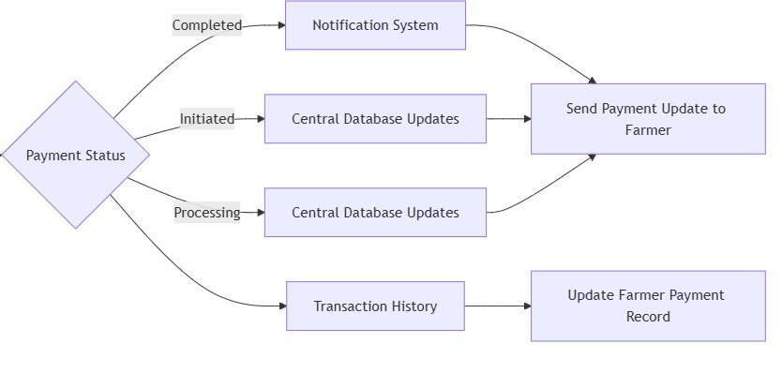
Fig. 01. Architecture of Farmer Payment Management Algorithm

Working and Process:
- Capture Crop Delivery Information: The system records the total weight of the crop delivered by the farmer. Retrieve the current rate per ton from the database based on the type and quality of the crop.
- Calculate Total Payment: Multiply the crop weight by the rate per ton to calculate the gross payment amount.
- Apply Deductions (if applicable): Deduct any applicable fees, such as transportation costs, taxes, or quality-based penalties. Calculate the net amount payable: Net Payment=Total Payment−Deductions
- Initiate Payment Process: Begin the payment process through the integrated payment gateway (e.g., Razor pay, Stripe). Set the payment status to "Initiated" in the database.
- Track Payment Status: Continuously check the payment gateway for updates on the transaction status. Update the status in the system as it progresses through stages: Processing: Payment is being handled by the gateway. Completed: Payment has been successfully made. Failed: Payment could not be completed; further action is required.
- Notify Farmer: Once the payment is completed, trigger a notification (using Firebase Cloud Messaging or SMS) to inform the farmer. The notification includes details like the payment amount, date, and transaction ID.
- Update Transaction History: Log the completed transaction in the farmer’s account history with details: Transaction ID, Payment amount, Payment date

Advantages:
- Increased Transparency: Farmers receive real-time notifications about payment statuses (e.g., initiated, processing, completed), which fosters trust and reduces the need for manual follow-ups on payments.
- Efficient Payment Processing: By automating the payment calculation based on crop weight, rate per ton, and applicable deductions, the algorithm minimizes errors and speeds up payment processing.

- Reduced Administrative Load: Automating payment calculations and updates lessens the administrative workload, allowing staff to focus on other critical tasks.
- Real-Time Updates and Notifications: With immediate updates to farmers via SMS or push notifications, the algorithm ensures that farmers stay informed, improving user satisfaction and reducing queries.

- Scalability: The algorithm can handle a high volume of transactions as it scales with Firebase or other backend services, making it suitable for sugar factories of various sizes.

Disadvantages:
- Dependency on Reliable Connectivity: Farmers in remote areas might have limited access to consistent internet or cellular service, which could delay notifications and payment updates.
- Complexity in Handling Deductions and Rate Fluctuations: The algorithm requires accurate and upto-date data on rates and deductions, which can be complex to maintain, especially if rates vary by crop quality or season.
- High Initial Setup and Maintenance Costs: Implementing and maintaining the system can be costly, particularly for smaller factories or those with limited digital infrastructure.

- Integration with Payment Gateways: If the payment gateway fails or has technical issues, the payment process could be disrupted, which may delay transactions and affect farmer satisfaction.

Limitations:
- Limited Customization for Diverse Payment Structures: The algorithm may not accommodate complex or customized payment structures, such as varied rates based on crop quality or location-specific incentives, without significant modifications.

- Offline Access Limitations: Although data can be saved offline temporarily, full functionality and realtime notifications require an active internet connection, potentially affecting accessibility for farmers in remote areas.
- Data Security and Privacy Concerns: As the system involves sensitive payment and personal data, ensuring secure storage and compliance with privacy regulations is essential, which may increase development and maintenance costs.
- Potential for Human Error in Data Entry: If crop delivery details or rates are entered manually, there is a risk of human error, which could affect payment accuracy. Automating data capture could help but may require additional infrastructure.

- System Downtime and Reliability: The algorithm relies on consistent uptime for real-time notifications and payment processing. Any server downtime or technical issues could lead to delayed payments and farmer dissatisfaction.

- Shareholder Analytics & Reporting Algorithm:
This algorithm gathers and analyses data related to crop yields, payment records, and shareholder investments, creating a comprehensive view of the factory’s production and financial metrics. It aggregates data to generate insights on production trends (such as peak production times), payment summaries, and financial performance metrics. These insights are presented to shareholders and administrators through visual reports on a dashboard, helping them track the progress of their investments and make data driven decisions.
Key performance indicators (KPIs) like production efficiency, payment status, and investment growth are calculated and visualized on dashboards in various formats, such as graphs, tables, and charts.

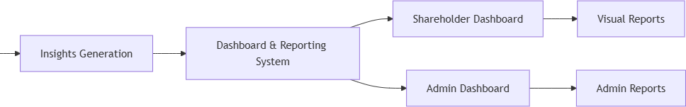

Fig. 02 Architecture of Shareholder Analytics and Reporting Algorithm Working and Process:
  - Aggregate Relevant Data: Gather data from the database, including: Crop yields from each farmer over time, Payment history of farmers, Investment records of shareholders (e.g., share value, dividends).
  - Calculate Key Metrics: For each metric, calculate relevant indicators to summarize performance: (Total Crop Production; Payment Summaries; Investment Growth3; Generate Insights and Trends)
  - Use data analytics techniques to analyze the aggregated data: Identify patterns, such as highest production periods or months with increased revenue. For financials, determine ROI and payment trends that show how shareholder investments are performing.
  - Visualize Data for Dashboard: Create visual representations (graphs, charts, tables) of the analysed data: Farmers: Display crop production over time, payment statuses, and pending payments. Shareholders: Show financial summaries, share performance, and dividends. Organize this information in a user-friendly dashboard layout for easy access and interpretation.

  - Display Reports and Enable Data Export: Present the insights and trends on the dashboard, accessible to shareholders and administrators. Allow users to export reports (e.g., PDF, CSV) for offline viewing or record-keeping.
  - Update Insights Regularly: Schedule regular updates to ensure that the data on the dashboard reflects the latest trends and transactions. Automatically refresh data and regenerate visualizations for shareholders and administrators to access the most up-to-date information.

Advantages:
- Improved Decision-Making: The algorithm provides real-time data and insights, allowing shareholders to make informed investment decisions.

- Enhanced Transparency: Shareholders get a clear view of the performance of the sugar factory, ensuring transparency in operations and dividend distribution.
- Automated Reporting: It can automate the generation of reports (e.g., financial statements, profit/loss), reducing manual efforts and errors.

- Better Risk Management: With data-driven insights, shareholders can assess risks associated with investments and plan accordingly.
- Personalized Dashboards: Custom dashboards can be created to track key metrics such as yield, investments, and profits, tailored to each shareholder’s interests.

Disadvantages:
- Complexity of Implementation: Developing an algorithm that can accurately handle multiple variables (e.g., investment amounts, yield, market fluctuations) can be complex.

- Data Dependency: The accuracy and quality of the output depend heavily on the input data. Incorrect or incomplete data can lead to misleading reports.
- Over-reliance on Automated Insights: Shareholders might rely too much on the algorithm's recommendations and ignore other important factors, such as market conditions or human judgment.

- Technical Issues: Bugs or errors in the algorithm might cause incorrect reporting, affecting shareholder confidence and decision-making.

Limitations:
- Limited by Historical Data: The algorithm’s predictions and insights may be based on historical data, which might not always reflect future trends, especially in volatile markets.
- Lack of Flexibility: Standard algorithms may not fully accommodate the unique goals or preferences of individual shareholders.

- Difficulty Handling Uncertainty: Predicting performance in agriculture-based industries like sugar production can be challenging due to factors like weather and crop health, which are outside the scope of the algorithm’s analysis.

- Inability to Account for External Factors: The algorithm may not consider all external factors such as global sugar market prices or political influences that could affect shareholder investments.

- High Maintenance: Continuous updates and modifications might be required to account for changes in business processes, external variables, or shareholder needs.

- APPLICATIONS

Farmer Payment Management Algorithm:

- Real-Time Payment Calculation: The algorithm can calculate real-time payments for farmers based on the quantity of sugarcane supplied, current market prices, and contractual agreements. This ensures that payments are automatically updated as the data is received.

- Instant Payment Transfers: Once the payment is calculated, the system can initiate instant bank transfers to the farmer’s registered bank account using APIs integrated with banking services. This provides farmers with immediate payment access.

- Payment Status Updates: Farmers can receive real-time updates regarding their payment status, such as payment confirmation, pending payment, or payment errors. Notifications can be sent via SMS, email, or inapp alerts.

- Real-Time Adjustment for Discounts/Bonuses: The algorithm can dynamically adjust payments based on real-time factors, like quality of the sugarcane, seasonal bonuses, or discounts on late deliveries. For example, a farmer’s payment could be adjusted based on how fresh or high-quality the crop is.

- Transaction History Tracking: The system can maintain a real-time, detailed history of all transactions, including past payments, deductions, bonuses, and any corrections. Farmers can track their payment history via the app.

- Dynamic Reporting: Shareholders and factory managers can access real-time reports showing the total amount paid to farmers, outstanding payments, and overall payment distribution, helping in decision-making and financial planning.

- Payment Dispute Resolution: The algorithm can also flag any discrepancies between expected and actual payments. In case of disputes, farmers can raise queries in real-time, and the system can generate automatic audit trails to resolve issues efficiently.

Shareholder Analytics & Reporting Algorithm:
- Live Financial Reporting: The algorithm can provide shareholders with real-time financial reports such as revenue, expenses, profits, and other key financial metrics. These reports can be updated automatically based on incoming data from transactions, production, and sales.

- Real-Time Dividend Calculation: Shareholders can view real-time calculations of their dividends based on the factory's performance. The algorithm can calculate how much each shareholder is entitled to based on their shareholding percentage, current profits, and other factors like bonus distributions.

- Stock Performance Monitoring: If your platform includes a stock or share trading element, the algorithm can track the real-time value of shares and display current stock prices, historical price trends, and performance comparisons, helping shareholders make informed decisions.

- Real-Time Production & Sales Data: Shareholders can access real-time data on sugarcane production, the amount of raw material processed, and the amount of sugar produced. This data helps shareholders gauge the company's performance and its impact on their returns.

- Real-Time Market Analysis: The algorithm can fetch market trends and global sugar prices, providing shareholders with insights into how external factors are influencing the factory’s performance. This helps in adjusting expectations and making data-driven decisions.

- Profit and Loss Dashboard: Shareholders can have a real-time, interactive dashboard that visualizes profits, losses, and operational efficiency metrics. Graphs, charts, and alerts can provide instant insights into how the factory is performing financially at any given moment.

- Shareholder Activity and Engagement Reports: The algorithm can track and report on shareholder activities, including voting on important issues, meetings attended, and the number of shares held. This helps ensure transparency and keeps shareholders informed about their involvement in company governance.

- CONCLUSION
The Farmer Payment Management and Shareholder Analytics & Reporting algorithms have proven instrumental in advancing transparency, efficiency, and user satisfaction within the sugar factory’s ecosystem. By automating payment calculations and tracking, the Farmer Payment Management Algorithm ensures that farmers receive accurate, timely payments while reducing administrative overhead. The integration of real-time notifications and tracking significantly strengthens trust between farmers and the factory, as farmers now have clear visibility into payment processes and statuses. The Shareholder Analytics & Reporting Algorithm empowers shareholders and administrators with detailed insights into production trends, financial metrics, and investment performance. By presenting data through visual, easy-to-interpret dashboards, the algorithm supports informed decision-making, thereby fostering more strategic investments and a deeper understanding of factory operations. Together, these algorithms not only streamline complex financial and operational workflows but also enhance stakeholder engagement and trust. Their design supports scalability, making the system adaptable for future expansion with advanced data analytics, predictive tools, or security features. In conclusion, these algorithms represent a transformative step toward a modernized, data driven approach in the agricultural sector, providing a replicable model that enhances efficiency, transparency, and connectivity in traditional industries.

REFERENCES
- R. Khara, D. Pomendkar, R. Gupta, I. Hingorani and D. Kalbande "Micro Loans for Farmers," 2020 11th International Conference on Computing, Communication and Networking Technologies (ICCCNT), Kharagpur, India, 2020, pp. 1-5, doi: 10.1109/ICCCNT49239.2020.9225577.
- Sai, P. K., Gupta, P., & Fernandes, S. F. (2019). Analysing Performance of Company through Annual reports using Text Analytics. 2019 International Conference on Digitization (ICD). doi:10.1109/icd47981.2019.9105673
- Piangor Loahavilai, Nopasit Chakpitak, Thunyaporn Jaimung (2017) Human Asset Management at the End-of-Life Phase” 11th International Conference on Software, Knowledge, Information Management and Applications (SKIMA)
- Zhang, Y. (2011). The Analysis of Shareholder Theory and Stakeholder Theory. 2011 Fourth International Conference on Business Intelligence and Financial Engineering. doi:10.1109/bife.2011.117
- C. Xu, Z. Jiang and C. Ma, "Research on Measuring Method of Farmers' Bearing Capacity to Agricultural Water Price," 2010 3rd International Conference on Information Management, Innovation Management and Industrial Engineering, Kunming, China, 2010, pp. 567-570, doi: 10.1109/ICIII.2010.616
- L. -a. Wang, F. -l. Zhong and X. -d. Guo, "A Research Framework of the Relationship between Payments for Environmental Services and Poverty Alleviation in China," 2009 First International Conference on Information Science and Engineering, Nanjing, China, 2009, pp. 4140-4144, doi: 10.1109/ICISE.2009.149
- "Kisan Suvidha" App for farmers: https://play.google.com/store/apps/details?id=com.dac.kisan

- Zerodha: https://zerodha.com

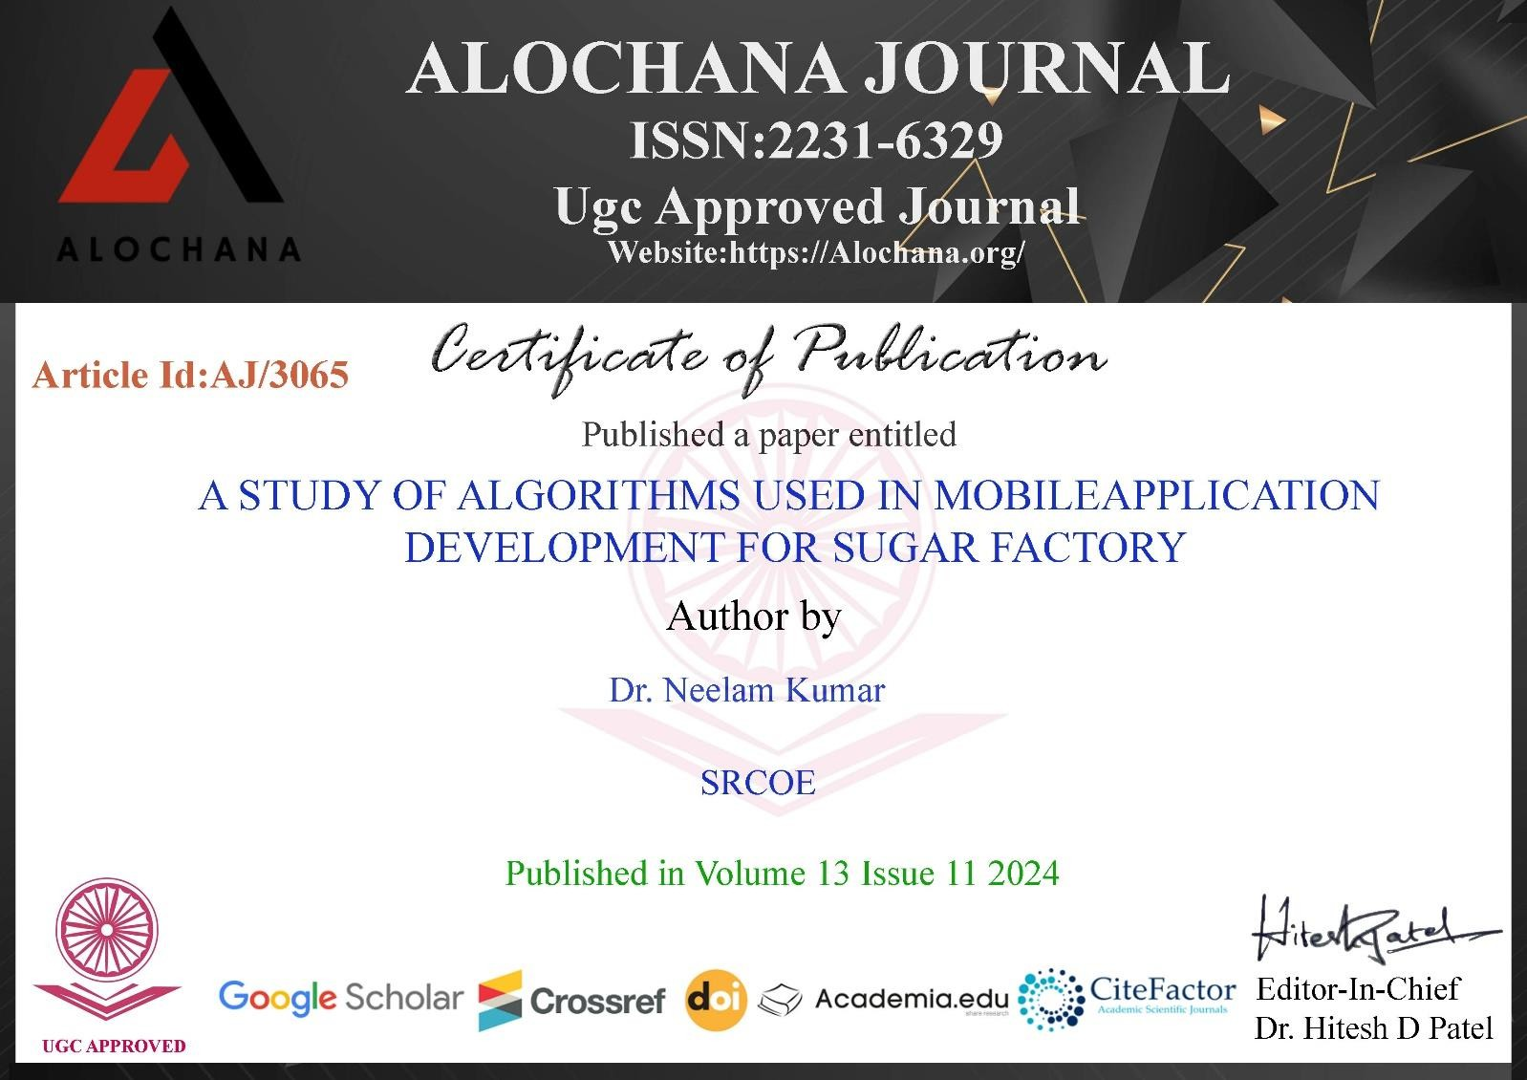
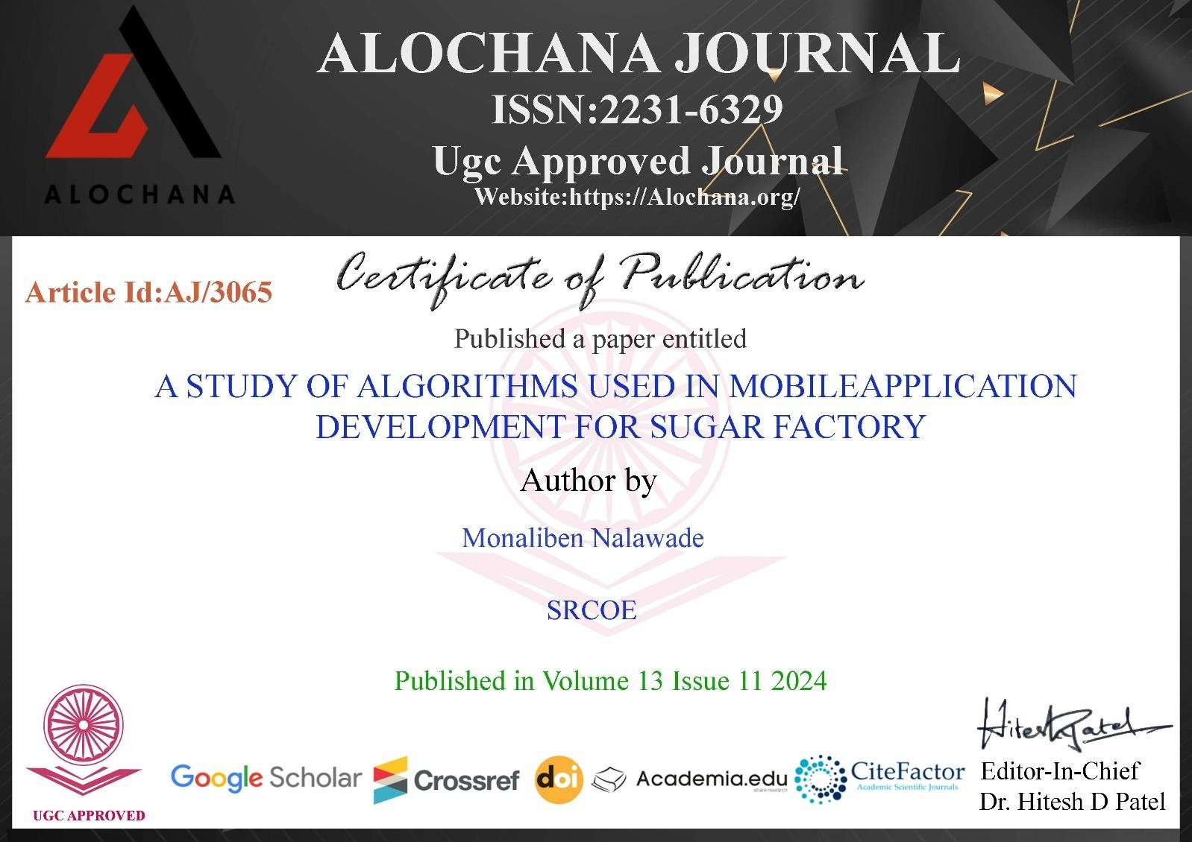

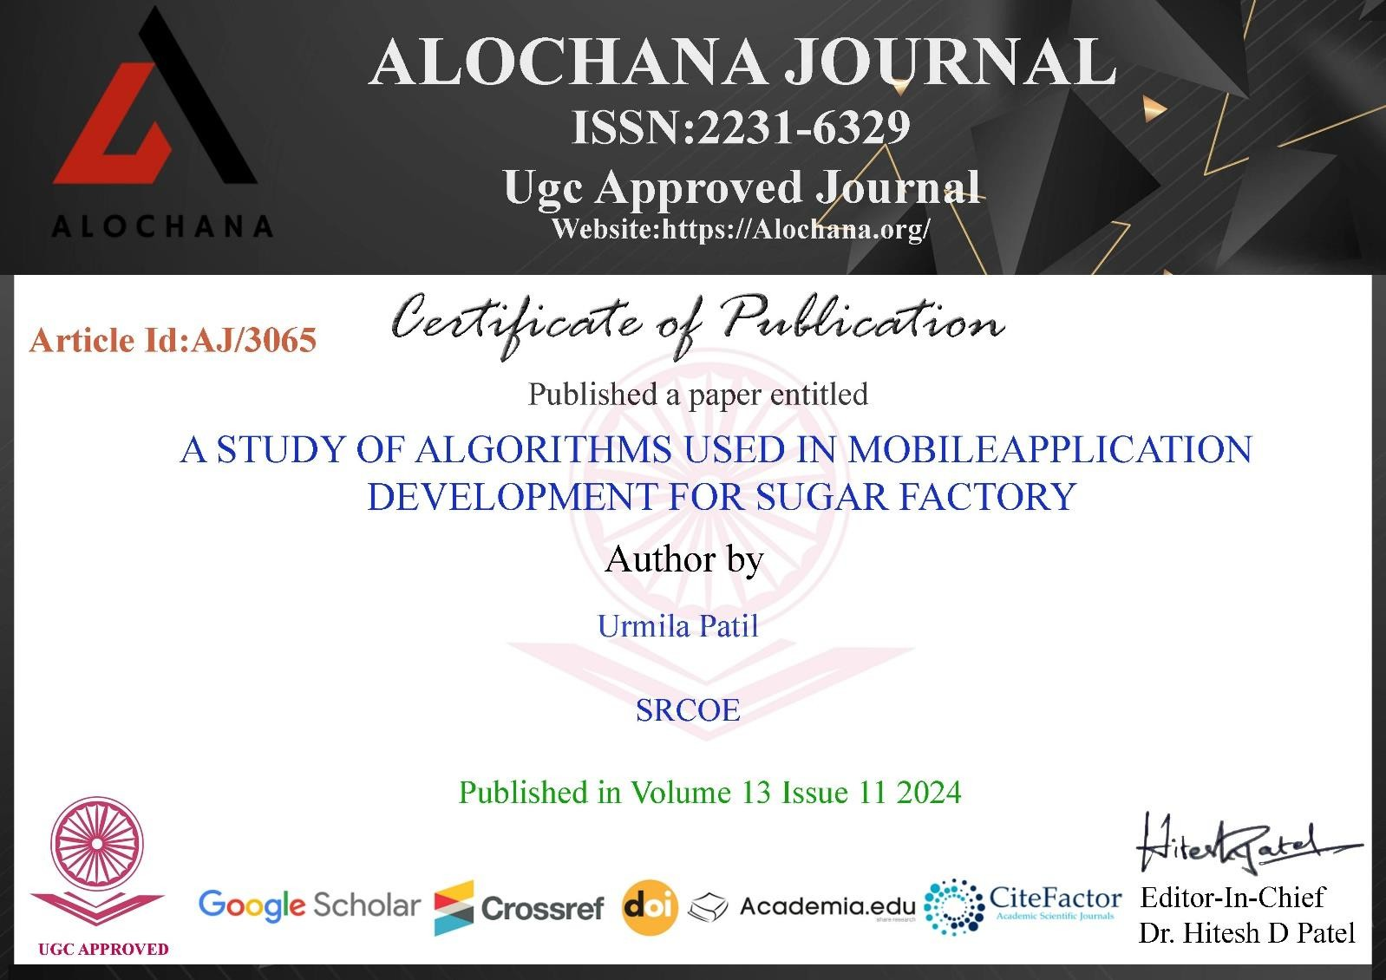
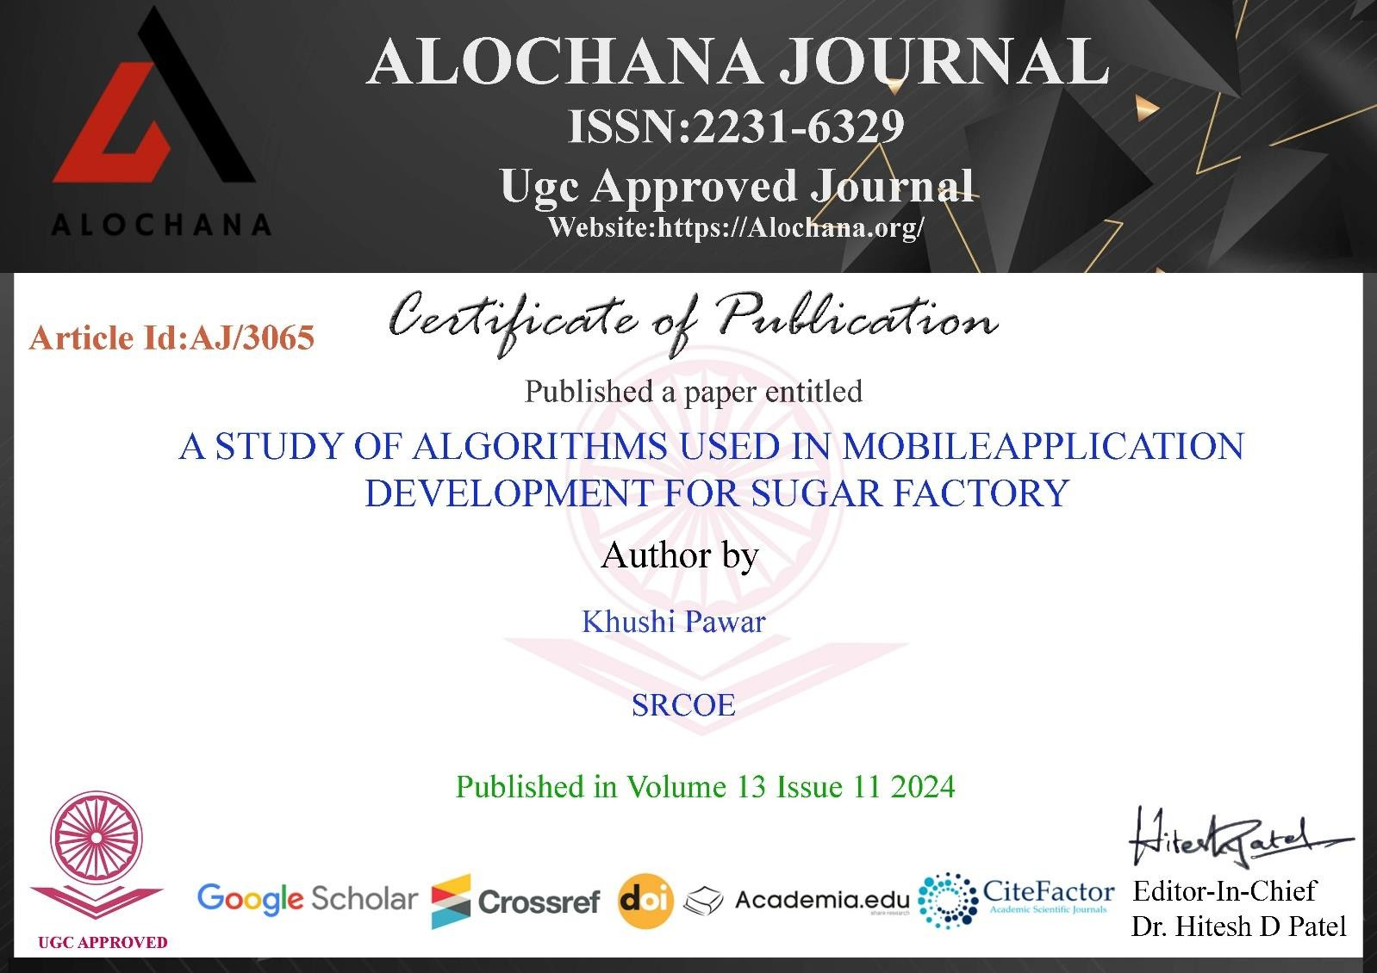

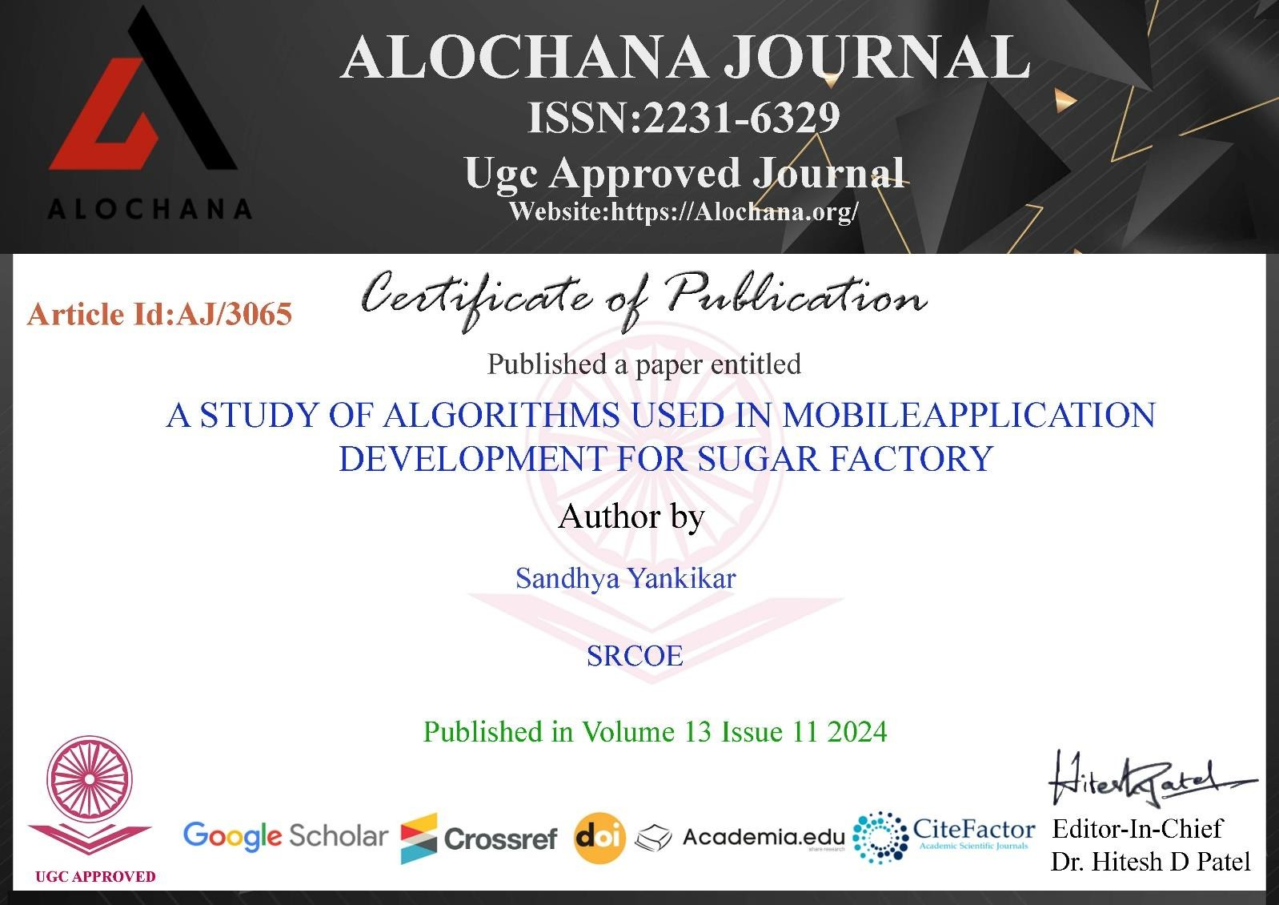

SWEET RETURNS: A MOBILE APP FOR SUGAR FACTORY'S FARMERS
Prof. Dr. Neelam Kumar¹, Monaliben Nalawade², Khushi Pawar³, Urmila Patil⁴, Sandhya Yankikar⁵
¹(Professor, SRCOE, Department of Computer Engineering, Pune)
², ³, ^{,4}, ⁵(Student, SRCOE, Department of Computer Engineering, Pune) Corresponding author: khushipawar.1203@gmail.com

Abstract: The Sugar Factory Application is a mobile-based solution developed to enhance communication and operational efficiency between sugar factories and their farmers. This application addresses the challenges posed by traditional manual systems by offering a streamlined, digital platform that provides timely access to crucial information. Built using Flutter and Dart, the application is designed with a user-friendly interface and is backed by a robust MySQL database through integration with the factory’s existing API. This project report focuses specifically on the implementation of the Farmer Module, which enables farmers to log in securely using role-based access control. Once logged in, users can access their personalized dashboard, view cane delivery details, check payment history, and receive real-time notifications regarding updates from the factory. A key highlight is the query support system that allows farmers to raise concerns or ask questions directly through the app, fostering better communication and transparency. The design of the application ensures accessibility for users with varying degrees of digital literacy, making it practical for widespread adoption in rural areas. Thorough testing, including functional and usability testing, was conducted to ensure the application performs efficiently and reliably across devices. The successful development and implementation of the Farmer Module demonstrate the potential of digital tools in transforming traditional agricultural industry workflows. This application lays the foundation for future enhancements and modules that can further automate and improve factory-stakeholder interactions, promoting efficiency, trust, and better service delivery.
Keywords: Mobile App Development, Farmer Payment Management, User Experience (UX), Real-time Data
- INTRODUCTION

The Agriculture is the backbone of India's economy, with sugarcane farming playing a crucial role in rural livelihoods. However, traditional methods of managing farmer factory interactions often lead to inefficiencies, delays, and a lack of transparency in financial transactions. To address these challenges, we have developed the Sugar Factory Application, a digital solution aimed at streamlining communication and financial management for farmers associated with sugar factories.
Currently, our focus is on the Farmer Module, which serves as a centralized platform for farmers to track their transactions, receive timely updates, and engage directly with factory administrators. This module is designed to replace manual recordkeeping and paper-based notifications with an automated system that enhances transparency and efficiency. By integrating technology into the sugarcane industry, the application helps bridge the gap between farmers and factories, ensuring smooth operations and better financial planning. The Farmer Module enables farmers to log in securely using a role-based authentication system. This ensures that only authorized users can access their financial records and other personalized information. Upon logging in, farmers can view their transaction history, which includes details of payments received for their sugarcane deliveries. This feature eliminates the need for manual bookkeeping and provides a clear, real-time overview of financial transactions.
In addition to financial management, the Farmer Module also includes a support and query resolution system. Farmers can submit their concerns directly through the application, allowing them to seek clarification on payments, deliveries, or factory policies. This eliminates the need for in person visits to the factory, saving time and effort. The support system ensures that all queries are addressed promptly, fostering better communication between the farmers and factory management. The implementation of this module is expected to bring several benefits to farmers. By enhancing financial transparency, it minimizes disputes related to payments and dues. The support services reduce dependency on intermediaries and minimizes miscommunication. Furthermore, by digitizing these processes, the application contributes to a paperless and ecofriendly approach in managing sugarcane transactions.
stake

- PROBLEM STATEMENT

To develop a mobile application for Sugar Factory’s Farmers.

- OBJECTIVES

- To develop a mobile application that serves the purpose of supporting farmers with agricultural practices and price updates.
- To act as a unified portal where farmers receive advice on sugarcane farming, weather forecasts, and market prices.
- To create a platform for real-time communication between farmers.
- To provide access to crucial data, including sugar prices, production reports, and market trends.

- LITERATURE REVIEW

Yang Nianjiong et al, in the paper "Research on Integrated Design Platform of Sugarcane Harvester," 2010, the authors have created an integrated design platform to develop a sugarcane harvester that solves the problems at the designing stage related to data integration and collaboration. This is a product data management (PDM) technology-based integrated design platform which integrates various CAD, CAE, CAPP, and CAM computer-aided systems integrated into a single package in terms of designing, analyzing, and manufacturing. This is essentially a low-cost solution meant to reduce high labour costs as well as productivity issues associated with traditional manual sugarcane harvesting, particularly in hilly topography where even mechanization is a challenge. Working under the umbrella of the National Science Foundation of China's support, Nianjiong's team designed this integrated system with an eye toward making the more efficient process of creating sugarcane harvesters possible by allowing data sharing, utilization of design files multiple times, and avoiding the repetition of work, thus accelerating the development cycle. The study concludes that an integrated design platform of a sugarcane harvester streamlines data handling, thereby increasing the overall process efficiency when it comes to complex electromechanical products like harvesters. The developed platform is thus a remarkable step toward modernizing the development of agricultural equipment and, particularly, for challenging terrains where traditional methods of harvesting are costly and labour-intensive.[1]
Piang-or Loahavilai et al., "Human Asset Management at the End-of-Life Phase" (2017), proposed a model to manage older workers in production settings, where their physical ability is compromised but intellectual capabilities are enhanced. The study seems to answer issues of concern to and the management, which cite that older workers contribute less to the firm compared to the young counterparts due to their physical inability. However, they own superior knowledge and experience that overwhelmingly enhances human capital. The paper examines a semiconductor assembly company in Thailand, whose average age of production workers increased in recent years, raising shareholder concerns about productivity and innovation. In that situation, the company implemented various early retirement measures, while also acknowledging the requirement for fair and effective criteria to assess the continued value of senior employees. This challenge is compounded by contrasting labour practices that are visible in Korea, where early labour force exit is commonplace, therefore changing expectations from for younger workforce demographics.[2]
Deepak Murugan et al. in the paper "Development of an approach for tracking Sugarcane Harvested and Non-Harvested situations the usage of Time collection Sentinel-1 data" (2018), suggest a methodology to reveal sugarcane harvest status the use of Sentinel-1 artificial aperture radar (SAR) information. Their technique leverages the common, unfastened availability of SAR records for agricultural tracking, addressing an opening in crop surveillance, mainly for sugarcane, thru a singular category system primarily based on temporal profiles and crop cycles. To distinguish harvested from non-harvested sugarcane, they evolved criteria based totally on the length of the crop cycle. Sugarcane, with a longer boom duration of over two hundred days, become without problems distinguishable from other plants. Temporal adjustments in backscatter had been used to stumble on the begin and give up of the crop cycle, with VH polarization particularly helpful in identifying vegetative states. For type, harvested and non-harvested sugarcane were separated primarily based on cycle period and start instances, allowing a general accuracy of 82.17% for identifying sugarcane conditions. [3]
Hari Singh et al. in the paper "Irrigation and fertigation scheduling effect on phenology and yield of spring sugarcane (Sachharum officinarum)" (2020) concluded that drip irrigation mixed with nitrogen software in six splits considerably improves the increase and yield of sugarcane as compared to traditional methods. carried out at Banaras Hindu university, the look at used a break up-plot design with 3 irrigation strategies (flood, furrow, and drip) and 5 nitrogen scheduling treatments (farmers' practice and splits in 4, 6, 8, and 10 packages). Drip irrigation

continuously produced superior outcomes in phrases of increase metrics, yield attributes, and ordinary productivity. Their study, published in the Indian Journal of Agricultural Sciences, investigates the effects of different irrigation methods and nitrogen application schedules on sugarcane growth and productivity. The results demonstrated that drip irrigation significantly improved sugarcane growth parameters, including the number of tillers, leaf area index, mill-able cane count, and cane yield. Compared to flood irrigation, drip irrigation increased cane yield by 22.30%.[4]
Santosh Kr. Gupta et al. in the paper "Predicting Total Sugar production the usage of Multivariable Linear Regression" (2021), supplied a model that predicts sugar manufacturing in multidimensional planes based on multivariable linear regression. This examine highlights the importance of accurate predictions for India, the largest sugar-producer inside the world, and the backbone activity concerned in handling its production to meet demand whilst making well-knowledgeable agricultural selections. The authors additionally make use of statistics from 1931 to 2018. records sources are extracted from Co-operative Sugar Vol. 51, No. 6, February 2020. several of the important thing variables worried encompass region below sugarcane cultivation, general sugarcane manufacturing, yield in step with hectare, and total cane crushed. The authors conclude that with multivariable regression, they are capable to reveal the efficacy of this technique for the prediction of sugar production, thereby offering insights beneficial to the sugar industry. [5]
Abdella Mohammed Ahmed et al., in paper "Determinant of Labor Supply in Metahara Sugar Factory: Case Study" (2024), conclude that quite a few socio-economic and demographic factors significantly influence decisions about labour supply within the factory. The focus of this study dwells on Ethiopia's MSF, with its principal drivers or determinants of labour force participation buttressed by age, marital status, income potential, educational level, fertility, and migration status. The research further shows that the participation rates of young and middle-aged groups are higher, peaking at ages 25-34 and then declining with age, which is a normal curve for labour force participation. Yield attributes such as cane weight and biological yield had been also considerably higher with drip irrigation and 6 split nitrogen packages. specifically, drip irrigation provided consistent soil moisture, main to more suitable biomass accumulation and most excellent situations for cane increase. The six-break up nitrogen treatment allowed for a regular nutrient deliver, aligning with the plant’s developmental needs and supporting extra mill able cane production. first-rate tendencies, including fibre and industrial cane sugar content material, showed minimal version throughout one-of-a-kind irrigation and nitrogen remedies, indicating that the stepped forward yield did no longer compromise cane first-class.[6]
Liang Yu et al., in the paper “A Research and Practice for Sugarcane Area's Farm Management Information Service Platform” (2010), proposed a comprehensive farm management information service platform aimed at enhancing sugarcane production efficiency, improving yield and quality, and ensuring the freshness of harvested sugarcane. The study addresses the key challenges in traditional sugarcane farm management in China, such as high production costs, inefficient harvesting and transportation, and weak coordination among farmers, enterprises, and government bodies. To mitigate these issues, the authors designed an integrated information system leveraging Remote Sensing (RS), Geographic Information Systems (GIS), Global Positioning Systems (GPS), and Web Services. The system also improved collaboration between farmers, sugar enterprises, and policymakers, leading to increased productivity and economic returns.It also concluded that incorporating advanced information technologies into sugarcane farm management is crucial for modernizing agriculture and achieving sustainability. [7]
Changxin Xu et al., in the paper “Research on Measuring Method of Farmer’s Bearing Capacity to Agricultural Water Price” (year of publication not provided), explored the concept of farmer bearing capacity, which refers to the ability of farmers to sustain agricultural production while managing various environmental, economic, and social challenges. The study states that several key factors—including land resources, financial stability, policy support, and market conditions—significantly influence a farmer's ability to maintain long-term productivity and sustainability. The authors emphasized that economic resilience, such as access to credit, government subsidies, and stable agricultural markets, enables farmers to invest in modern technologies and manage market risks effectively. They also highlighted environmental sustainability as a core element of agricultural resilience, identifying soil degradation, water scarcity, and climate change as major threats. The paper proposes solutions like conservation agriculture, improved irrigation systems, and crop diversification to promote long-term sustainability and maintain soil health. Social and policy dimensions were also discussed, noting that government initiatives, farmer cooperatives, and technical training programs are essential in equipping farmers with modern techniques and fostering information-sharing. Strengthening rural infrastructure and networks was recommended to enhance resilience further. [8]
Rushabh Khara et al., in the paper “Micro Loans for Farmers: A Path to Financial Inclusion” (year of publication not provided), stated that microfinance plays a crucial role in supporting small-scale farmers by providing them with access to financial resources that are otherwise unavailable through traditional banking systems. The study emphasizes that microloans help farmers overcome financial barriers, boost agricultural productivity, and promote

rural economic development. The authors proposed that incorporating financial literacy, digital banking, and flexible repayment plans could improve the effectiveness of microlending. Khara et al. concluded that while microloans are a powerful tool for rural empowerment, careful implementation and supportive policies are essential to prevent financial distress and ensure long-term impact. [9]
S. Thuankaewsing et al., in the paper “Using an Artificial Neural Network and a Mathematical Model for Sugarcane Harvesting Scheduling” (year of publication not provided), concluded that technological integration, such as artificial intelligence and mathematical modeling, is essential for improving the efficiency of sugarcane harvesting and overall sugar factory operations. The study emphasizes the economic significance of sugar production in both agricultural and industrial sectors and highlights the need for operational efficiency to maintain competitiveness. Waste management and environmental sustainability were also addressed. The authors explored the reuse of sugar industry byproducts such as bagasse, molasses, and press mud, highlighting their potential in power generation, ethanol production, and organic farming. They advocated for the adoption of eco-friendly practices and compliance with environmental regulations. The authors concluded that the future of the sugar industry depends on embracing digital tools, enhancing workforce skills, and establishing efficient logistics. A collaborative effort among policymakers, factory owners, and farmers is crucial to modernize the industry and ensure its long-term sustainability. [10]
Bruno Moraes Rocha et al., in the paper “Evaluation and Detection of Gaps in Curved Sugarcane Planting Lines in Aerial Images” (year of publication not provided), proposed that aerial imaging combined with computer vision techniques can significantly improve the detection of planting gaps in sugarcane fields, especially in non-linear, curved plantation layouts. The study addresses the limitations of traditional manual gap detection methods, which are often labor-intensive, error-prone, and inefficient for large-scale plantations. The authors utilized high-resolution aerial images captured via drones and remote sensing tools to analyze sugarcane field conditions. These images underwent preprocessing and were analyzed using advanced image processing techniques such as edge detection and segmentation. A key contribution of the research is the use of machine learning models capable of distinguishing between normal plant spacing and unintended gaps, even in curved planting lines, where traditional straight-line-based algorithms fall short. The system developed in the study automatically identifies planting discontinuities and evaluates their severity, enabling more efficient and accurate monitoring of field health. [11]
Zin Mie Mie Aung et al., in the paper “Farmers’ Knowledge, Attitude and Practice on Integrated Pest Management in Kalaw Region, Myanmar” (year of publication not provided), concluded that the Myanmar Engineering Society (MES) plays a vital role in supporting the country’s engineering and infrastructure development. The paper emphasizes that MES serves as a professional platform promoting collaboration, technical advancement, and national development through engineering excellence. The authors state that MES contributes significantly to infrastructure projects by offering expert consultation, research insights, and technical solutions, ensuring that engineering practices in Myanmar align with international standards. MES’s collaboration with government bodies, private entities, and global organizations is highlighted as a key driver in the modernization and sustainability of the country’s engineering sector. Furthermore, the study proposed that MES’s capacity-building initiatives—including training programs, workshops, and conferences—are essential for updating the technical skills of Myanmar’s engineers and bridging the gap between academic education and industrial requirements.[12]
- SOFTWARE & HARDWARE REQUIREMENT

For End-users (Farmers/):
- Smartphones/Tablets (Android): Android 5.0 (Lollipop), Android 8.0 (Oreo) or above, 2 GB RAM or more, 100 MB free space
For Admin Users (Desktop/PC):
- OS Windows 10 or higher / macOS 10.13 or higher, Intel Core i3/i5, 8 GB - 16 GB RAM, 10 GB free space, Stable broadband connection
For Cloud based Backend (Firebase):
- Database Server: Intel Xeon, 16 GB RAM, 1 TB SSD Storage, Highspeed Ethernet
- Web Server: Intel Xeon, 8 GB RAM, 256 GB SSD or more

- SYSTEM ARCHITECTURE

System Architecture Diagram:
Fig. VI.2. Sugar Factory Application Architecture Diagram
- DATA FLOW DIAGRAM

Level 0: Context Diagram

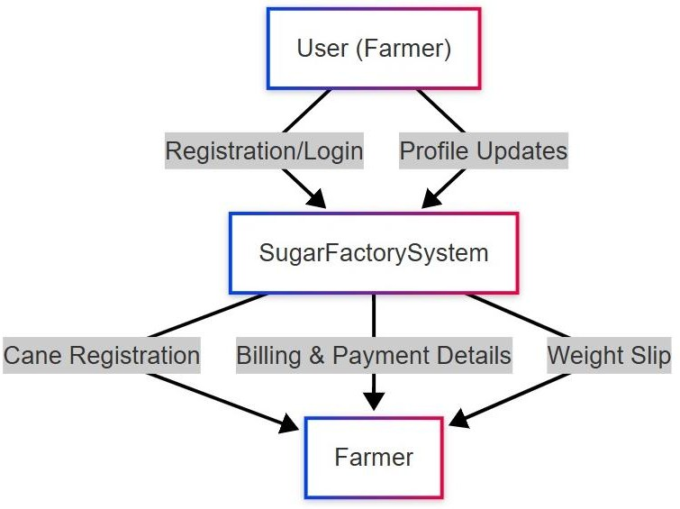  Fig. VI.2. Sugar Factory Data Flow Diagram | The diagram shows three modules in Sugar Factory System: User will Login and can update profile on Sugar Factory App. The farmer can do the Cane Registration & Weight Slip and Sugar Factory will display Billing and payment details.
Level 1: Farmer Process Flow

Farmers can login and perform three operations as: Profile Managements, Cane Registration & Enter Weight Slip. At last, they can also see the payment bill.

Fig. VI.3. Farmer’s Data Flow Diagram
Level 2: Farmer Cane Registration Flow

Farmer will enter cane data, it will be validated, then saved to database, this will generate Registration ID which will be returned to a farmer. He will also receive notification updates.

Fig. VI.5. Farmer’s Cane Registration Flow Diagram

  - ENTITY RELATIONSHIP DIAGRAM

Fig. VI.6. Farmer Module ER Diagram

Here, Admin approves farmer’s cane registration, Farmer has Cane Registration, Farmer submits weight slip, Admin approves bills and farmer receives it.
- RESULTS




Fig. 9.1. Index Page | Fig. 9.2. Login Page | Fig. 9.3. Farmers List

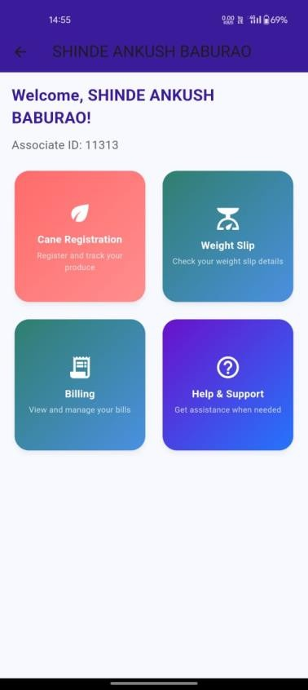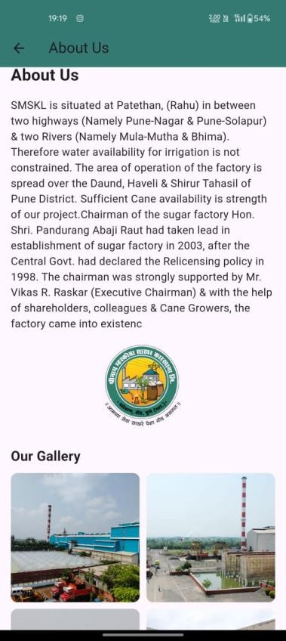

Fig. 9.4. Farmer’s Dashboard | Fig. 9.5 Farmer Profile | Fig. 9.6 About Us

Fig. 9.7. Contact Us | Fig. 9.8. Cane Registration | Fig. 9.9. Cane Weight Detail

Fig. 9.10. Cane Bill Details | Fig. 9.11. Cane Bill Deduction | Fig. 9.12. Logout Page

- ADVANTAGES
- Real-time Data and Updates: Farmers, , and admins benefit from real-time data synchronization. For instance, farmers can instantly see updates on cane registration approvals, billing information, and payment statuses. This reduces delays and improves operational efficiency.
- User-friendly Dashboard: The app offers user-friendly dashboards for Farmers, , and Admins, allowing them to manage their respective operations (cane registrations, payments, dividends, etc.) with minimal technical skills.
- Offline Functionality: The app’s ability to function in offline mode ensures that farmers in rural areas can still register cane or submit weight slips without requiring continuous internet connectivity. Data is synced when connectivity is restored, ensuring that the user experience is seamless.
- Scalability: Firebase’s backend services (Authentication, Firestore, Cloud Functions, and Cloud Messaging) automatically scale based on user load, allowing the system to accommodate increasing numbers of users without significant architectural changes.
- Secure Authentication and Role Based Access: Firebase Authentication provides secure login and registration mechanisms. Role based access control (RBAC) ensures that each user only has access to the features relevant to their role, providing data security and reducing risks of unauthorized access.

- DISADVANTAGES
- Internet Dependency for Critical Features: Although the app supports offline data entry, critical features such as billing, payment processing, and real-time notifications depend on an active internet connection. This could be a disadvantage for users in rural areas with poor connectivity.
- Higher Costs as the System Scales: Firebase is an excellent choice for a scalable backend service, but as the system grows, costs can increase due to storage, read/write operations, and real-time database usage. Migrating to a paid plan will be necessary to support high traffic and usage.
- Potential Latency in Remote Areas: Farmers in rural or remote locations with weak internet connections may experience latency in data synchronization or notification delivery. This may result in delays in updating payment statuses or receiving notifications about cane registration approvals.

- Reliance on Third-party Payment Gateway: The system is dependent on third party payment gateways (like Razor pay, Stripe) for payment processing. If these services experience downtime or technical issues, payments could be delayed, which might lead to dissatisfaction among farmers and .
- Security Risks: Handling sensitive data like Aadhaar numbers, PAN details, and bank account information comes with inherent security risks. If there are any vulnerabilities in the system (such as inadequate encryption or weak authentication), it could lead to data breaches, resulting in loss of trust and possible legal repercussions.
- APPLICATION
- Cane Registration Management: Digital system for farmers to register sugarcane delivery schedules. Reduces manual paperwork and scheduling conflicts.
- Payment Handling System: Automates payment processing for farmers. Ensures transparency and timely disbursements.
- Real-Time Updates and Notifications: Instant alerts for payment status, cane collection, meetings, etc. Keeps all users well-informed and engaged.
- AI and Predictive Analytics (Future Scope): Provide yield predictions and personalized farming advice. Detect anomalies in crop health or productivity.
- Blockchain for Secure Transactions (Future Scope): Maintain tamper-proof records of payments and contracts. Increase trust among farmers and .
- CONCLUSION

The Sugar Factory Application provides an innovative and comprehensive solution for managing cane registrations, payments, and real-time updates. By leveraging Flutter for cross platform mobile development and Firebase for scalable backend services, the application is well-suited for use in rural areas, helping Farmers, , and Admins streamline their operations. The future scope of the project opens exciting opportunities for expansion. By integrating advanced technologies like AI, blockchain, IoT, and predictive analytics, the application can offer farmers personalized insights, enhanced security for payments, and real-time crop management. Expanding the application to other agricultural sectors or integrating financial services and government programs can increase its utility across multiple domains. In conclusion, the Sugar Factory Application is poised to be a powerful tool for agricultural management, improving efficiency, transparency, and user experience for all users. As technology and user needs evolve, the application can adapt and scale, offering increasingly sophisticated solutions for the agricultural industry.
- FUTURE SCOPE

The current implementation of the Sugar Factory Application includes a fully functional Farmer Module that streamlines access to essential information such as payment history, delivery updates, and notifications. However, there is considerable potential for future enhancements to broaden its utility and impact. Future versions could introduce dedicated Shareholder and Admin Modules—enabling shareholders to track dividends and shares, and administrators to manage operations, generate reports, and handle queries efficiently. Adding multilingual support would enhance accessibility for non-English speaking users, while AI-based analytics and forecasting could offer predictive insights on sugarcane yield, market prices, and personalized recommendations. Offline functionality would ensure usability in low-connectivity areas by allowing data to sync once internet access is restored. Additionally, SMS integration can reach users without smartphones, and linking the app with government schemes would help farmers access subsidies and welfare programs more conveniently. Finally, transforming the basic query system into a full-fledged grievance redressal system with ticket tracking would improve transparency and build user trust.
REFERENCES

- N. Yang, "Research on Integrated Design Platform of Sugarcane Harvester," 2010 International Conference on Measuring Technology and Mechatronics Automation, Changsha, China, 2010, pp. 105-108, doi: 10.1109/ICMTMA.2010.252.
- P. -o. Loahavilai, N. Chakpitak and T. Jaimung, "Human asset management at the end-of-life phase," 2017 11th International Conference on Software, Knowledge, Information Management and Applications (SKIMA), Malabe, Sri Lanka, 2017, pp. 1-8, doi: 10.1109/SKIMA.2017.8294115.
- D. Murugan and D. Singh, "Development of an Approach for Monitoring Sugarcane Harvested and Non-Harvested Conditions Using Time Series Sentinel-1 Data," IGARSS 2018 - 2018 IEEE International Geoscience and Remote Sensing Symposium, Valencia, Spain, 2018,
pp. 5308-5311, doi: 10.1109/IGARSS.2018.8518261.
- Singh, H., & Singh, R. K. (2020). Irrigation and fertigation scheduling effect on phenology and yield of spring sugarcane (Sachharum officinarum). The Indian Journal of Agricultural Sciences, 90(6), 1054-1057.

- S. K. Gupta and A. P. Agarwal, "Predicting Total Sugar Production Using Multivariable Linear Regression," 2021 International Conference on Computing, Communication, and Intelligent Systems (ICCCIS), Greater Noida, India, 2021, pp. 465-469, doi: 10.1109/ICCCIS51004.2021.9397078.
- Ahmed, Abdella. (2024). DETERMINANT OF LABOR SUPPLY IN METEHARA SUGAR FACTORY CASE STUDY ON METEHARA SUGAR FACTORY. doi:10.13140/RG.2.2.34625.36962.
- Liang Yu and Luo Yongjun, "A research and practice for sugarcane area's farm management information service platform," 2010 International Conference on Computer Application and System Modeling (ICCASM 2010), Taiyuan, China, 2010, pp. V9218V9221, doi: 10.1109/ICCASM.2010.5623050.
- C. Xu, Z. Jiang, and C. Ma, "Research on Measuring Method of Farmers' Bearing Capacity to Agricultural Water Price," 2010 3rd International Conference on Information Management, Innovation Management and Industrial Engineering, Kunming, China, 2010, pp. 567
- R. Khara, D. Pomendkar, R. Gupta, I. Hingorani, and D. Kalbande, "Micro Loans for Farmers," 2020 11th International Conference on Computing, Communication and Networking Technologies (ICCCNT), Kharagpur, India, 2020, pp. 15, doi: 10.1109/ICCCNT49239.2020.9225577.
- S. Thuankaewsing, S. Pathumnakul and K. Piewthongngam, "Using an artificial neural network and a mathematical model for sugarcane harvesting scheduling," 2011 IEEE International Conference on Industrial Engineering and Engineering Management, Singapore, 2011, pp. 308312, doi: 10.1109/IEEM.2011.6117928.
- B. M. Rocha, G. da Silva Vieira, A. U. Fonseca, H. Pedrini, N. M. de Sousa and F. Soares, "Evaluation and Detection of Gaps in Curved Sugarcane Planting Lines in Aerial Images," 2020 IEEE Canadian Conference on Electrical and Computer Engineering (CCECE), London,
ON, Canada, 2020, pp. 14, doi: 10.1109/CCECE47787.2020.9255701

- Z. M. Mie Aung, N. Arunrat, S. Sereenonchai, M. Yuttitham, T. N. Stewart and W. Chaowiwat, "Farmers' Knowledge, Attitude and Practice on Integrated Pest Management in Kalaw Region, Myanmar," 2020 International Conference and Utility Exhibition on Energy, Environment and Climate Change (ICUE), Pattaya, Thailand, 2020, pp. 1-7, doi: 10.1109/ICUE49301.2020.9307118.
- "Kisan Suvidha" App for farmers: https://play.google.com/store/apps/details?id=com.dac.kisan

- Zerodha: https://zerodha.com

